Universal Access Symbols
Universal Access Symbols help visitors, potential audiences and staff identify accessible events at a glance. You can use the symbols in online and printed promotions, newsletters, conference brochures, online and printed programs, membership forms, building signs, floor plans and maps.
By including the symbols in your promotional materials, you are demonstrating that you are access aware. You are making all visitors feel welcome – for example, using a ‘wheelchair accessible’ symbol also tells patrons who use prams, walking frames or who have other mobility issues that your building is easily accessible.
The Graphic Artists Guild (USA) has created a set of free Universal Access Symbols, which you can download in a variety of formats.

Access Support Workers Symbol
Indicates Access Support Workers are available.
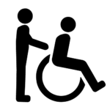

Accessible Toilet Symbol
Designed for people with physical impairments and as a safe space for everyone who uses the bathroom.
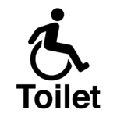

Assistance Animal Facilities Symbol
Indicates facilities for assistance animals. Can include seating, water, grass area or that the animal can be left with staff.
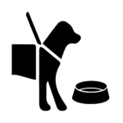

Assistive Listening Symbol
Assistive listening systems (augmented hearing, or hearing loop) are installed in many venues and are used to amplify or enhance sound quality via hearing aids, headsets or other devices. They include infrared, loop and FM systems. Portable systems may be available from the same audio visual equipment suppliers that service conferences and meetings.
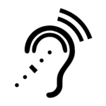

Audio Description Symbol
Audio description enhances live performance, film and visual art for people who are Blind or have low vision. Using a small radio receiver, the person receives a spoken description of visual elements by an audio describer.
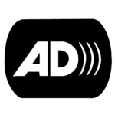

Auslan Symbol
Using the Sign Language Interpreting symbol tells Deaf Australian Sign Language (Auslan) users that Auslan interpreting is provided for a performance, film, guided exhibitions tour, forum, workshop or event. Interpreting makes sure Deaf Auslan users can engage with the performance or event using their first language.
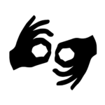

Blind or Low Vision Symbol
This symbol can be used to indicate access for people who are blind or have low vision, including: a guided tour, a path to a nature trail or a scent garden in a park; and a touch/tactile tour or a museum exhibition that may be touched.
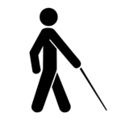

Braille Symbol
Braille indicates that written materials are available in Braille. This could include labelling, marketing, publications and signage at the venue.
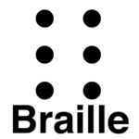

Captioning (open/closed)
Captioning is available at selected performances, movies, TV shows and online. During the performance, presentation, forum or film, the captions are displayed on a screen, enabling the audience to read what is being said, without obstructing the actors.

Open captioning is always in view, and cannot be turned off.
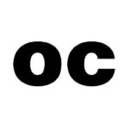

Closed captioning can be activated or deactivated by the viewer.

Companion Card Symbol
Indicates that the provider is a Companion Card Affiliate. The Companion Card is issued to people with disability who require lifelong attendant care support, to enable participation at events, activities and venues without incurring the price of a second ticket for their companion. www.companioncard.gov.au
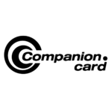

Easy Read Symbol
Indicates Easy Read is available. Easy Read documents have short, simple sentences with pictures.

Guide Dog Symbol
Guide dogs assist people who are blind or vision impaired. This symbol also refers to assistance animal.
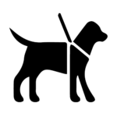

Large Print Symbol
Large Print is printed in 18 point or larger text. As well as indicating that large print versions of books, pamphlets, museum guides and theatre programs are available, you can use the symbol on conference or membership forms to indicate that print materials can be provided in large print. Sans serif with good contrast is highly recommended as well as following clear print guidelines for readability.

Quiet Space Symbol
A space to facilitate the calming or alerting of senses as needed. Quiet spaces are used to avoid or recover from sensory overload or to provide sensory input to meet a sensory need (e.g. tactile, auditory or visual stimulation). Also known as a chill out area or zone.
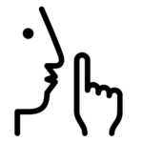

Registered Assistance Animals welcome Symbol
Indicates that only registered assistance dogs are welcome. This symbol also refers to Guide dogs.

Relaxed Event Symbol
Relaxed performances, screenings or events are designed to reduce anxiety and create a supportive atmosphere for people with autism spectrum conditions, learning disability and other sensory and communication disorders. There is a relaxed attitude to noise and movement among the audience and some small changes made to the light and sound effects. Audience members can enter and exit the venue throughout the show.

Relaxed event symbol

Relaxed performances symbol

Visual Eye Symbol

100 Symbol
No music or dialogue or all dialogue is open captioned.
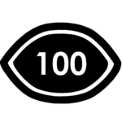

75 Symbol
Fully open captioned providing access to spoken word but no background music or sounds.
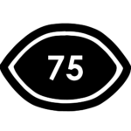

50 Symbol
May have music or sounds in the background, or may be partly open captioned or scripts and descriptions are given to the audience before the event on request.
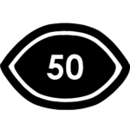

Visual Story Symbol
Using both words and pictures, a visual story introduces people on what to expect during an outing to the theatre, cinema or other activities. They should be short, factual, offer positive options to help with fears about triggers such as loud sounds, tell the story briefly, and share any big surprises.

Wheelchair Accessible Symbol
Indicates access for people with limited mobility, including wheelchair users. For example, the symbol is used to indicate an accessible entrance, bathroom or that a phone is lowered for wheelchair users. Remember that a ramped entrance is not complete access if there are no curb cuts, and an elevator is not accessible if it can only be reached via steps.
