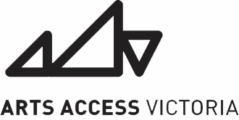
Nexus 2021
Expression of Interest form

If you have any questions about this application, or would like to submit it in an alternative format, we encourage you to contact us on 9699 8299 or at esifis@artsaccess.com.au

Name:
Date of birth:
Email address:
Preferred phone contact number (SMS or speech preference?):
Pronouns:
Do you identify as a Deaf and/or Disabled person? Yes / No
Do you identity as Aboriginal or Torres Strait Islander?: Yes / No / Prefer not to say
Do you identify as culturally diverse? Yes / No / Prefer not to say

Do you need an interpreter? (If so what kind?)

- What is your current artistic practice? (Maximum 300 words)

- Do you have any goals for your artistic practise that you want to develop? (Maximum 300 words)

- What are your artistic professional development needs/desires? (Maximum 300 words)

- We will be providing a support worker. Do you have access requirements? This may be related to your injury or may not be. If you have any concerns or to speak over any of your access need please feel free to contact us.

