|  |
| --- |
| QUT Icon  **QUT Research Project: Image and video Release** |

**Title of Research Project**

Evolution of Disability Arts in Australia

**QUT Ethics Approval Number 2021000382**

**    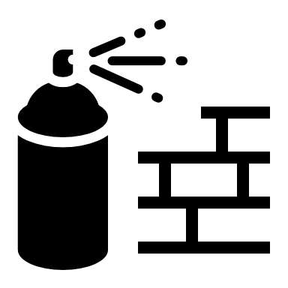 Arts Therapist**

**About the Research Team**

The lead chief investigators below and meet more of our research team in the information sheet.

|  |  |
| --- | --- |
| Profile picture of Bree HadleyProf Bree Hadley  Chief Investigator  QUT  [bree.hadley@qut.edu.au](mailto:bree.hadley@qut.edu.au)  Profile picture of Katie Ellis  Prof Kathleen Ellis  Chief Investigator  Curtin University  [katie.ellis@curtin.edu.au](mailto:katie.ellis@curtin.edu.au)  Profile picture of Michael Whelan  A/Prof Michael Whelan  Chief Investigator  QUT  [m.whelan@qut.edu.au](mailto:m.whelan@qut.edu.au) | Profile picture of Eddie PatersonA/Prof Edward Paterson  Chief Investigator  The University of Melbourne  [eddiep@unimelb.edu.au](mailto:eddiep@unimelb.edu.au)  Profile picture of Janice Rieger  A/Prof Janice Rieger  Chief Investigator  QUT  [j.rieger@qut.edu.au](mailto:j.rieger@qut.edu.au) |

**Image and video release**

When you participate in this research, we will be taking photographs and video recording you.

The research team wants to use this photographs and video recordings when they create an archive of disability arts in Australia, and in other publications and research presentations, created as part of this project, funded by the Australian Research Council, and supported by QUT.

When the research team does this, this will identify you, it is possible that people will become aware that you have been part of the research.

You will have the opportunity to view the photographs, and the video recording, before we use them, and decide whether you would like to say yes or no to us using them.

Once the image and video are published it will not be possible to withdraw your consent for us to use them.

You can say no without any consequences.

You can say no and still take part in the research.

If you agree to have your images used, please complete and sign the consent below.

If you want to review your image prior to use, please tick yes.

**Any questions?**

If you have any questions about the research, or questions about what you need to do, then:

Question Icon

* Do not complete this form yet.

Email icon

* Send Bree an email on [bree.hadley@qut.edu.au](mailto:bree.hadley@qut.edu.au) and we can arrange a time to answer your question.

**Statement of consent**

* Do you understand the information about image release?

Yes / No

* Have your questions about the research been answered to your satisfaction?

Yes / No

* Do you understand that you can ask more questions at any time?

Yes / No

* Do you understand that you can say no to releasing image during the project, but, after it is published, it will not be possible to withdraw consent?

Yes / No

* Do you understand that if you are worried about the ethics of this research, you can ring the QUT Research Ethics Adivsory Team on 07 3138 5123, or send them an email at [humanethics@qut.edu.au](mailto:humanethics@qut.edu.au).

Yes / No

**Only sign this form:**

* if you are sure you understand what you will be asked to do,
* if you are sure you understand what it means for you and other people if you take part.
* if you have answered yes to all the questions above.
* And if you have decided you would like to take part in the research.

**Please tick the relevant box below:**

I **agree** to QUT using images of me in this research.

**I would like to review** images of me before they are used in this research.

No.

Yes. Please provide your email address below.

|  |  |
| --- | --- |
| **A B C D …**  **Print your full name here:** |  |
| Email icon  **Your email address:** |  |
| **Signature Icon**  **Signature**  **Sign here:** |  |
| **Date:** |  |

You can sign the form, or, if you prefer, I can video record you telling me you want to take part, either verbally in words, or in sign language.

**Please return the signed consent form to the researcher.**

**A copy will be provided for your records.**