Spill
An exhibition by Nimbus Studio

Wednesday 29 June – Friday 22 July

Seventh Gallery, 215 Church Street, Richmond

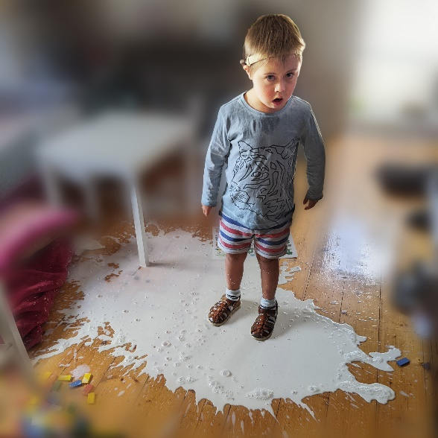

Jane Tomlinson, Jasper, 2022.

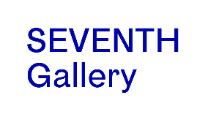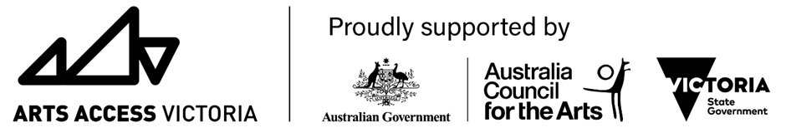

Nimbus studio considers the idea of spill. reflecting how they subvert, transform and re-imagine both real and imagined boundaries. Their work reclaims, rethinks and reshapes understanding of Deafness and Disability. They find respect, pride and sense of place. They push the boundaries and challenge thinking of disability and artistic practice.

There are many different boundaries in art:

boundaries of style

material boundaries

aesthetic boundaries to mention a few.

Boundaries exist to limit and exclude Disabled and Deaf people. These boundaries are not fixed or permanent. They constantly shift and are often invisible.

We need to spill over and out of these social and cultural boundaries. To promote art that pushes, extends and explores the boundaries. To explore what it looks like, how it's made and the people who make it.

Spill considers the disruptive potential of disability. It reflects upon its ability to unsettle mainstream thinking.

QR code below for playlist of audio descriptions of all artworks. Inidvidual artwork audio description QR codes are on the following pages.
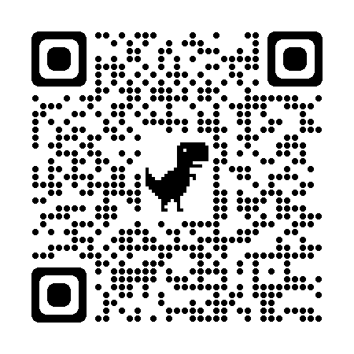

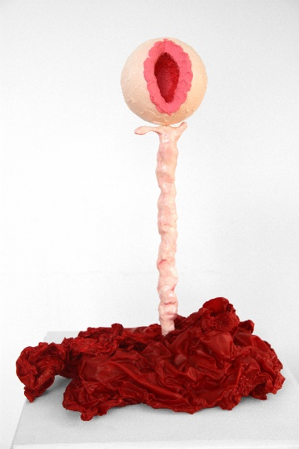

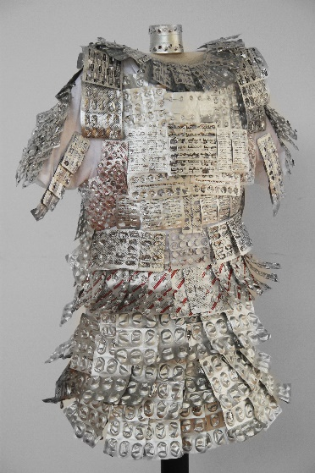

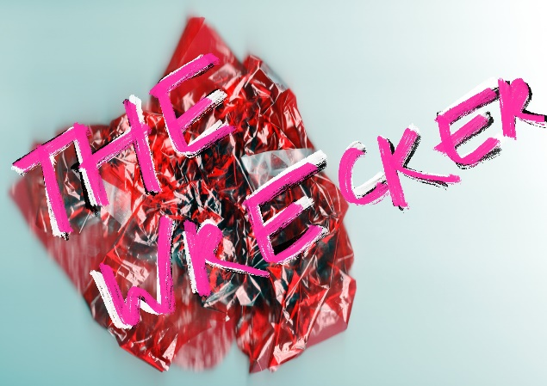

Artist as Sheila by Jane Tomlinson
Mixed Media, 2022
50 X 40 X 65 cm
$375
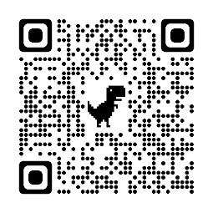

Battle Armour by Aleshanee Faery

Mixed Media Sculpture, 2022

1.8m high

NFS

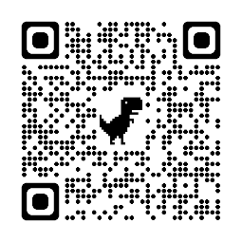

The Heart Exposed by Brigette Griffiths Mark

Dry inkjet on foam core, 2022

15 x 21 cm
$137
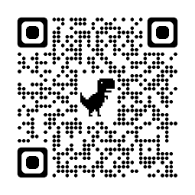

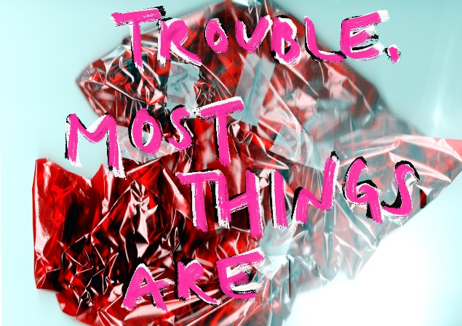

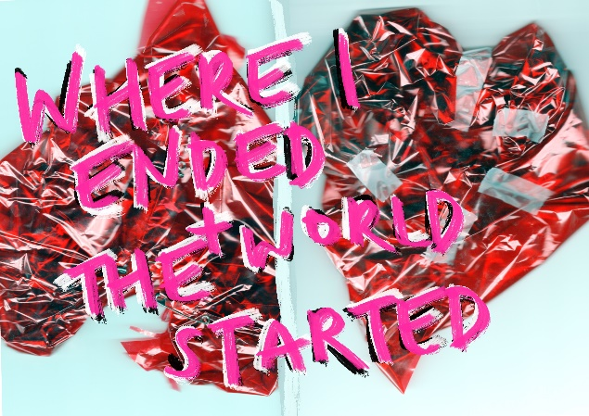

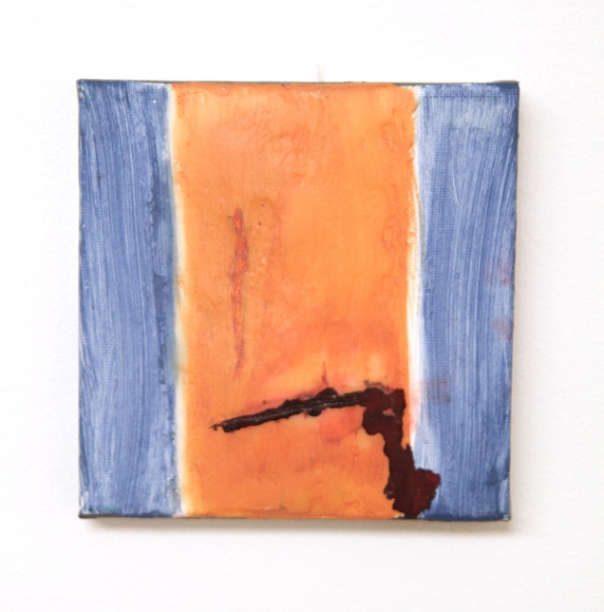

Tulle Skirts by Brigette Griffiths Marks

Dry inkjet on foam core, 2022

15 x 21 cm
$137
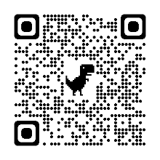

Twins or Mirrors by Brigette Griffiths Marks

Dry inkjet on foam core, 2022

15 x 21 cm
$137
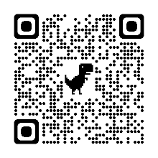

Blood by Warren Loorham (Woz)
Painting, 2022
15cm X 15cm
$63
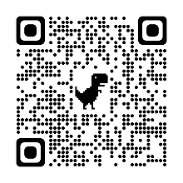
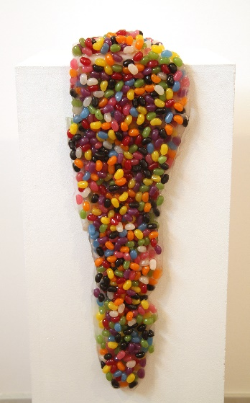
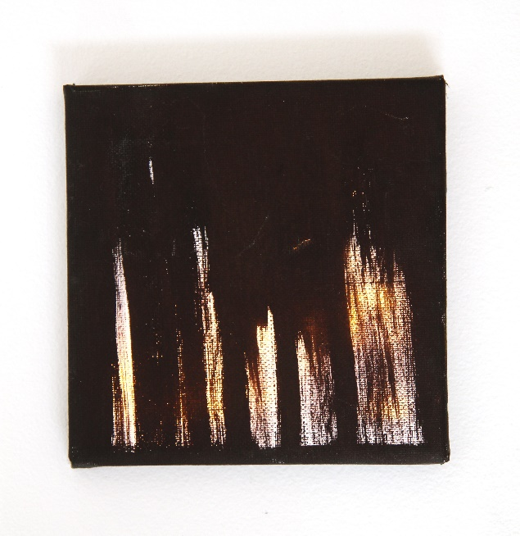
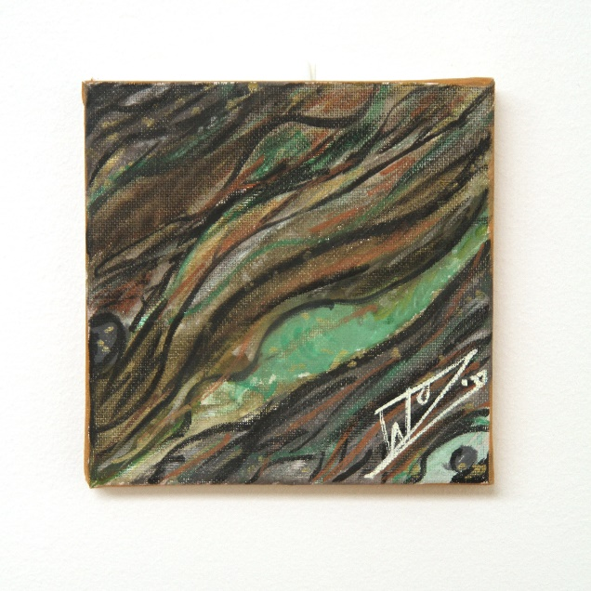

Jelly Beans by Warren Loorham (Woz)
Painting, 2022
15cm X 15cm
$188
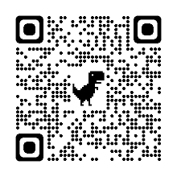
Light Spill #1 by Warren Loorham (Woz)
Painting, 2022
15cm x 15 cm
$63
Oil by Warren Loorham (Woz)
Painting, 2022
15cm X 15cm
$63
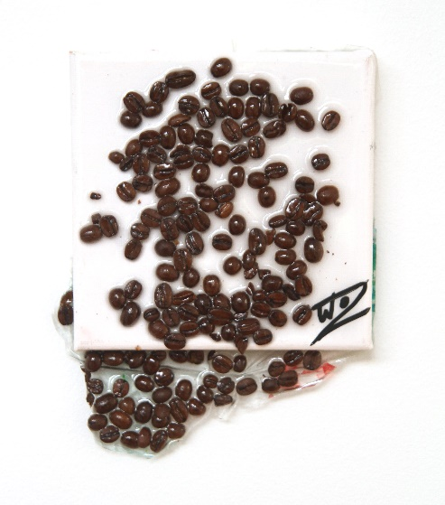

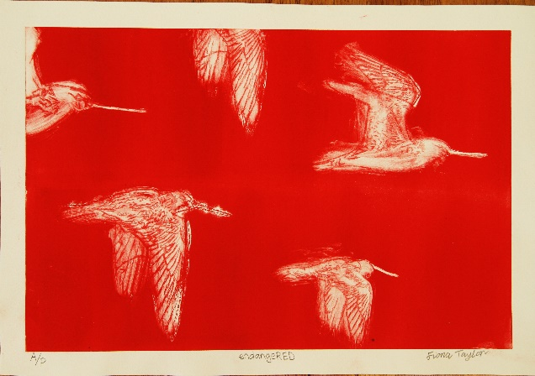

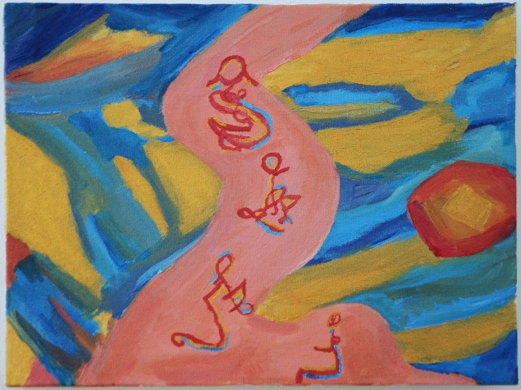

Spill the Beans by Warren Loorham (Woz)
Painting, 2022
15cm X 15cm
$63

endangered by Fiona Taylor
Dry point etching print framed, 2022
44.5 x 62cm
$187
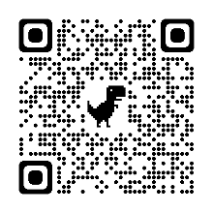

Starry Night by Angela Blazevic
Acrylic paint on Canvas Collage, 2022
40cm X 30cm
NFS
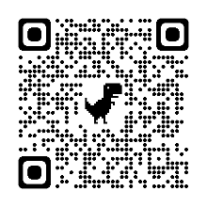

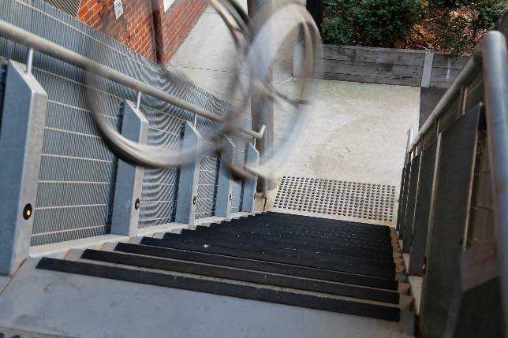

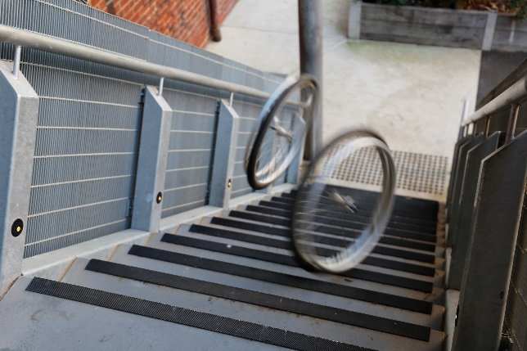

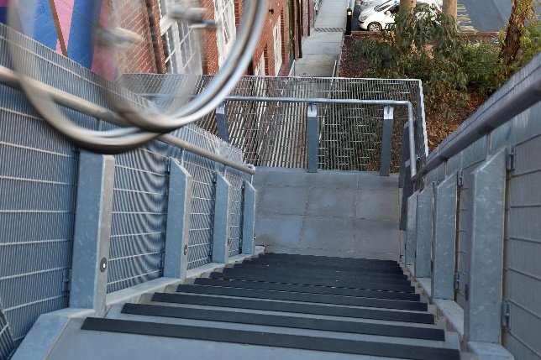

Stairs 1 by Nicole Tsourlenes
Digital inkjet on Foam core, 2022
21.0 x 29.7 cm
$175
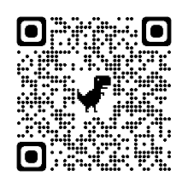
Stairs 2 by Nicole Tsourlenes
Digital inkjet on Foam core, 2022
21.0 x 29.7 cm
$175

Stairs 3 by Nicole Tsourlenes
Digital inkjet on Foam core, 2022
21.0 x 29.7 cm
$175

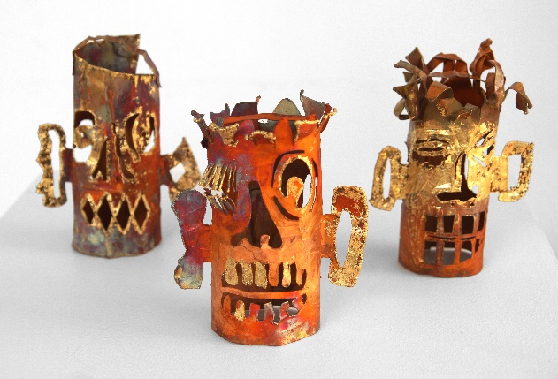

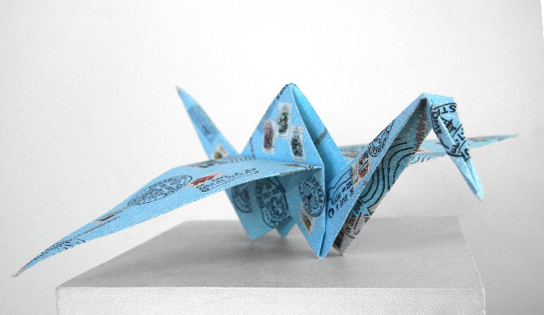

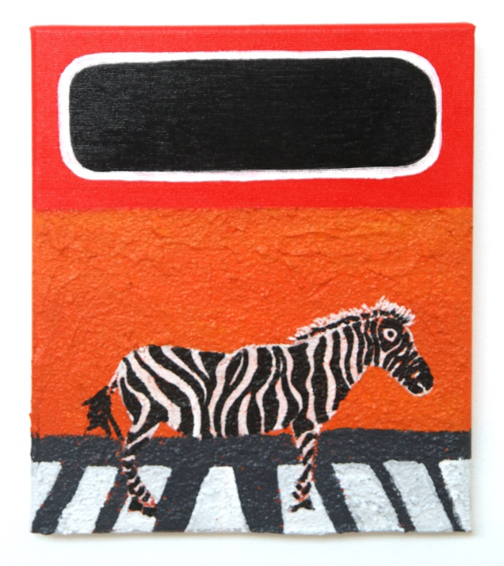
Do you ever find it strange to be yourself by Penny Pollard
Sculpture, 2022
12cm to 40cm
Small works $250 Larger works $437
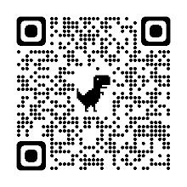

The Spills of History by Larissa MacFarlane
13 Linocut blocks and found postage stamps on Japanese paper, 2022
60x60x20cm
$875
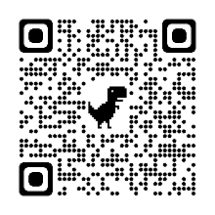
Zebra Crossing by Raymond Martin
Painting, 2022
30cm x 20 cm
$250
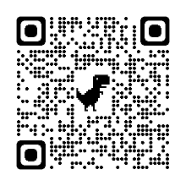
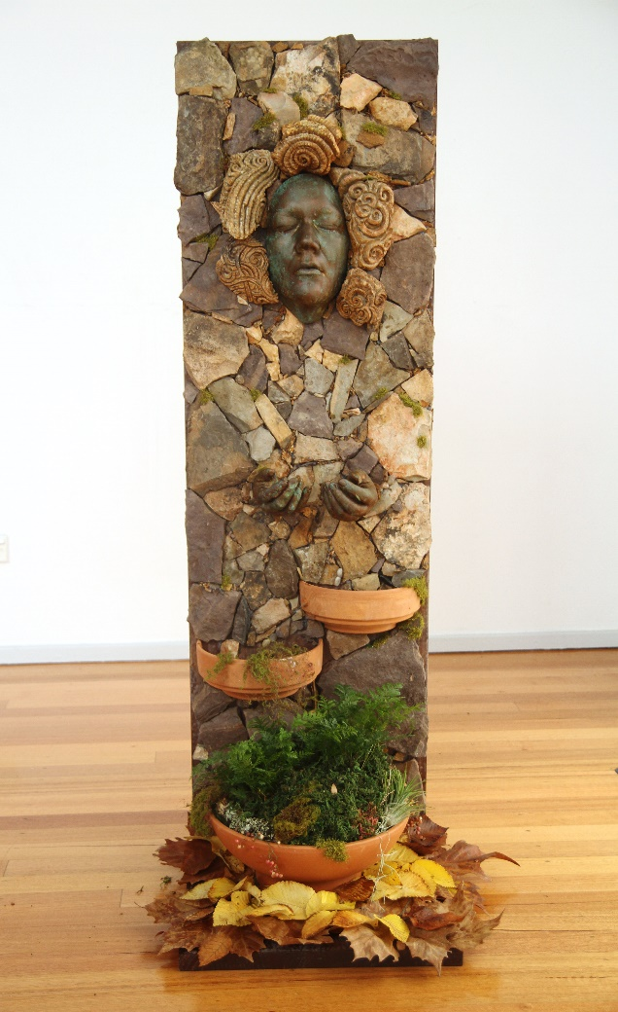

Woodland Fountain by Marnie Woods
Sculpture, 2022
135 X 40 X 45 cm
$3,750
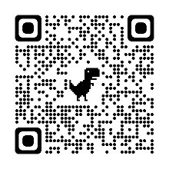

Artist Statements:
Angela Blazevic
Angela’s work is about advocacy around disability, spiritualism and important world topics. In her recent work, Angela gets inspiration from Van Gogh's Starry Night. She is also inspired by Aboriginal depictions of colour, light and harmony. For Angela it is important that we live in balance, night and day birth and death while everything is in harmony. She likes to capture texture, in this work Angela has focused on portraying the soft skyline. In this painting these ethereal figures immerse and spill themselves into the stars.
Aleshanee Faery
SPILL
Pill
Ill
Spill your guts
Bloodspill
Spilt milk
Nausea
Suicide
Prescription medications
Battle Armor is an imperfect protection. Clever weapons penetrate chinks in the armour. Heavy armor impedes ease of movement.
Prescription medications have similar benefits, drawbacks and risks. The Consumer Medicine Information (CMI) leaflets list common and rare side effects. Some have an additional specific warning of suicidal thoughts or behaviour.

Raymond Martin
A black and white striped zebra is standing still on a grey and white zebra crossing.
The zebra crossing is in the desert, which takes up the bottom two thirds of the canvas. It is painted with orange and textured sand made from dirt and sand mixed in with molding paste. The sky above the desert is red with an obelisk shaped planet. It is painted in black with a white edge to signify that the planet is in solar eclipse. No two zebras have the same stripes. Just like a fingerprint they are unique to that one animal.
The orange colour of the desert broken by the black and white appearance of the eclipse. It is also broken by the black and white of the zebra, the black and white colours of the obelisk planet. and the imagined sound of the zebras hooves on the crossing.
Without the big bang, you would not have the zebra, or the crossing, or the planet, or the obelisk. If it wasn’t for the sun, the zebra wouldn’t have its stripes as the pigment in the zebras stripes is due to the sun.
We are all space dust.
Fiona Taylor
Fiona has chosen to print in red, the mighty migratory shorebird the Bar Tailed Godwit. This highlights their endangered status and raises awareness for this species miraculous undertakings. These remarkable creatures fly from the Arctic Circle to Australia and New Zealand and back again - a round trip of some 29,000 kilometers. This work reflects the spill in a number of ways. The birds fly into and out of the boundaries of the print in reference to their plight. They also spill out of their nesting grounds due to habitat loss.
Penny Pollard
“Do you ever suddenly find it strange to be yourself?” - Clarice Lispector
Sculptural copper masks, hang in space and make a constellation. Twisting at the end of the lines create chance face-to-face encounters of self and other. A simple selection of copper, gold leaf, white paint and oxidation is used to make the work. Penny thinks about masks and how people can put on a mask to act any way they want. People change all the time and enjoy many types of social settings. Our dreams and inner thoughts are important to our personality. Filipino gold funerary masks are an ongoing source of inspiration. These masks can protect, decorate or hide what lies inside. The floating masks have different fragments and move in space. Penny wants the viewer to think about all the ways people think, feel and enjoy life. And how people's personality always moves or spills out.
Nicole Tsourlenes
In this exhibition, Spill, my work reflects the inaccessibility of the world around us. Part of the social model of disability says, "People are disabled by barriers in society". Buildings not having ramps is an example of this. In this work the stairs represent what is wrong with building accessibility. The issue sits with the community, not with the person.
Woz (Warren Loorham)
Woz’s exploration of the concept spills off the canvas, metaphorically spilling over imposed societal boundaries. Using a variety of mediums, Woz represents "Spill" in multiple configurations, both traditional and contemporary. His creative process explored physical actions contexulising the movement expected when one hears the word "Spill"!
Jane Tomlinson
Jane is self-taught and takes a DIY approach to exploring her mediums. She enjoys challenging the viewer to interpret the form, creating their own story. Jane’s work explores ambiguity of dreams and forms, inflicting it on the audience with an air of mystery. Jane’s sculpture is an abstract interpretation of the ancient European Sheela-Na-gig carvings. They themselves hold mystery on their interpretation and intent. Exploring the female anatomy with cheeky energy, she elevates the womb to a place where there is no shame. This artwork explores the idea of being vulnerable and embracing sexuality after childbirth. It also speaks of trauma and living life with a disability.
Larissa MacFarlane
This hand printed folded paper crane is part of a new larger project that looks back upon our past and the present Covid times. It includes almost all the postage stamps of 1981. Sport, royalty, nationalistic pride and white settler history were important themes in 1981. It was also International Year of Disabled Persons. Featured is a stamp that is one of the very few that represents disabled people. This July, 41 years later, Disability Pride Month is celebrated in Australia. For many disabled people this will be their first time. This artwork features new invented postmarks that challenge a colonialist history. One that continues to perpetuate systemic injustices such as racism and ableism.
Bridgette Griffiths Mark
Bridgette created this series after much indecision and exploration of Spill. Bridgette was questioning why she couldn't quite stick to a point of view about the theme. Inspired by the creativity, honesty and passion of the other Nimbus members - she went to write all she felt on Spill, writing a poem. Lead by the truth telling of spilling, she has created colorful, bold and playful prints to capture the heart, release and pains of a Spill.
Marnie Woods
The idea for ‘Woodland Fountain’, is from Marnie's dreams of a forest and the ruins of an ancient temple.
The water flowing from the eyes and mouth and through the hands connect to both tears and speech. An overflowing of emotion without any intrinsic negativity. The water flowing through her hands tells of the ability to make art out of suffering. A favourite means of the artists self-expression.
This type of media is new to Marnie, and the first time she has created artwork of this scale. Designed with hand gathered moss and stone, the face and hands are cast from her own body. This fountain combines her affinities with both Nature and Spiritualism.

