Arts Access Victoria:

VicHealth Co-Design Research Report

## Contents:

Introduction 4

About Arts Access Victoria 4

Definition of Disability 4

About this report 5

Acknowledgements 5

Communities and Locations 6

Community 6

Locations 6

Which communities were consulted? 7

The Youth Advisory Committee 7

The Co-Design Collaborators 7

Auslan Focus Group 8

Survey respondents 8

What Methods Did We Use? 9

Youth Advisory Committee 9

Co-Design Workshops 9

Research 12

Survey 13

Research and consultation findings 14

From the Co-Design Collaborators and Youth Advisory Committee: 14

Survey findings 16

Literature Review (Dr. Margaret Mayhew) 25

Key findings from desktop research 30

What has been developed? 31

Values 31

Program Ideas 32

Evaluation 33

### We recognise and pay our deepest respect to the traditional custodians of the land and acknowledge their rich heritage and deep insights from which we can all learn.

# Introduction

## About Arts Access Victoria

Arts Access Victoria is the peak body for arts and disability in Victoria. We are a disability-led organisation leading transformational and systemic change for Deaf and Disabled artists, arts workers, creatives and audiences. You can read more about our work here: <https://www.artsaccess.com.au/about/>

## Definition of Disability

At Arts Access Victoria, everything we do is guided by the Social Model of Disability. It was developed by [Deaf and Disabled people](https://www.artsaccess.com.au/about/our-language/) to point out and fight discrimination. It is there to help Deaf and Disabled people live their lives the way they want to. And it shows the world how to include Deaf and Disabled people based on equality and human rights.

It recognises that people are disabled by the barriers created by society. A barrier might be physical, like a building only having stairs and no lift. Another barrier might be the way people communicate or behave.

By using the word ‘disability’ to mean barriers and discrimination, we involve everyone in identifying and removing those barriers and in acting against discrimination.

## About this report

This report comprises findings from research undertaken with Arts Access Victoria’s Youth Advisory Committee, Youth Co-Design Collaborators, survey results from 50 respondents, survey analysis and a literature review from Dr. Margaret Mayhew (Specialist Projects Associate at AAV) as well as a summary of the Children and Young People with Disability Australia (CYDA) Budget submission from 2020-2021 by Dr Margaret Mayhew. Margaret is a researcher, artist and activist in Gender, Sexuality, diversity and cultural studies. The Co-Design Group was facilitated by Kochava Lilit (zey/zir or they/them) is a Jewish queer disabled activist, writer, and educator. This report was compiled by Arty Owens, Creative Producer Youth Programs and Sarah Fiddaman, Manager Artist Support Services at Arts Access Victoria. If you would like to receive this report in another format, please contact us at the details below.

[AOwens@artsaccess.com.au](mailto:AOwens@artsaccess.com.au)

[SFiddaman@artsaccess.com.au](mailto:SFiddaman@artsaccess.com.au)

Phone: 03 8640 6007

## Acknowledgements

Signal/City of Melbourne, Always Live, Future Reset Collective, VicHealth, Department of Family Fairness and Housing, Victorian Government, Music Market, Music Victoria, Arts Centre Melbourne, Collingwood Yards, Emerging Writer’s Festival

# Communities and Locations

## Community

Our target community is Deaf and Disabled artists, creatives and audiences aged 17 – 25.

The Deaf and Disabled community is diverse. It’s not a monolith. We all experience the world differently, have different access needs and often have conflicting opinions when it comes to our community. So, in consulting with our community we wanted to make sure we had a broad range of experiences being heard. However, we acknowledge that we won’t be able to represent everybody. And those we did not reach have not been forgotten.

As Arts Access Victoria currently delivers arts program for school-aged students, we decided to focus on the transition years when young Deaf and Disabled people leave the schooling system and are finding their path in life.

## Locations

Arts Access Victoria (AAV) exists for all Deaf and Disabled people in Victoria. For Future Reset we focused on the Melbourne metropolitan area with opportunities to connect in regional areas through our Future Reset partners. There are significant barriers for young Deaf and Disabled people in Melbourne, even though it is better resourced than non-metropolitan areas in the rest of Victoria.

# Which communities were consulted?

## The Youth Advisory Committee

The Youth Advisory Committee was established with 8 young Deaf and Disabled artists and arts workers aged 17 - 25. The purpose of the Youth Advisory Committee is to:

* Leave the decision-making power with young Deaf and Disabled Artist
* Develop current and future AAV programs
* Develop a long-lasting relationship with young members of our community. Meaning they have ongoing engagement with AAV not just a one-off consultation.
* Help us build programs for Future Reset.

The members were recruited in an open call out and were selected via a panel of three AAV staff member.

## The Co-Design Collaborators

The purpose of these co-design groups was to gain insights from young Deaf and Disabled people in relation to the ambitions of the Future Reset program. The outcomes will form the base of our proposal to VicHealth for development in 2023-2024.

The AAV Co-Design Workshops were made of 12 Deaf and Disabled artists aged 17 – 25 from backgrounds including regional, immigrant backgrounds, LGBTQIA+, carers and POC. We extended an offer to those who weren’t selected to be part of our Youth Advisory Committee to join the Co-Design Workshops. Knowing our community and how much energy it takes to send in applications, this was a way to remove that barrier. This was also a way to build trust and replace the feeling of rejection with a new opportunity.

We also reached out to people in our existing programs and within our broader networks in order to gain a mix of experiences. An invitation was also extended to members of the Youth Advisory Committee, to provide ongoing opportunities to connect with community.

## Auslan Focus Group

In our consultations and research, we wanted to make sure Deaf and Hard of Hearing artists were included. We engaged Jess Moody to run an Auslan only focus group. This would create a comfortable space for Auslan users to communicate freely.

We had a financial initiative, connected with Deaf organisations and circulated an [Auslan flyer.](https://youtu.be/rFw-LKE7d8Y) In the end we didn’t have enough numbers to move forward with the focus group.

Jess gave us these reasons why we didn’t reach the young Deaf and Hard of Hearing community:

* An increase in Deaf/Hard of Hearing people not identifying as Disabled
* There is an increase in the younger generation of people who don’t use Auslan (use spoken English) as a result of being mainstreamed
* It’s common for people in their late 20s to learn Auslan and join the community later in life

## Survey respondents

Approximately 50 young people aged 17-25 participated in an online survey.

# What Methods Did We Use?

## Youth Advisory Committee

The Youth Advisory committee met four times between August and December 2022. In the first committee meeting, the members decided on a meeting structure and developed a set of guiding principles. The meetings are held via Zoom to accommodate access and to make the meeting COVID safe. Each meeting is Auslan interpreted and live-captioned. The meetings are two hours. This is to leave time for breaks, processing information and have social time.

The committee provided insights on how to make better online programs, how to develop social connections in our programs, how we can reach young Deaf and Disabled artists and audiences and how we can better represent young people in our marketing.

## Co-Design Workshops

There were five co-design workshops facilitated by Kochava Lilit with 12 young Deaf and Disabled artist collaborators both in-person at Arts Access Victoria, Signal and online. Workshops were delivered on consecutive Sundays in October/November 2022 and were three hours in length, hybrid, catered and had artistic materials for free use. The timeframe gave the collaborators enough time to feel comfortable, think deeply about the programs and not feel rushed. The workshops were also on Sunday to suit the schedule of the collaborators, some of whom were still in school. Workshop collaborators were paid at industry rates to participate.

### Hybrid and Online Participation

AAV has an ongoing commitment to make our programs hybrid. Everything we do is also available online in some way. As COVID still has a presence, many members of the Deaf and Disabled community don’t feel safe attending in-person. Having an online version means that people can safely collaborate with AAV.

It also means that people in regional areas can participate without traveling long distances. Also, it took the pressure off if people were too sick to attend in person.

### Zine Making

As part of the first workshop, collaborators were asked about creative documentation. How they would like themselves and their ideas to be represented. In the end they decided on creating a Zine together. The fourth workshop was a Zine Making workshop. Also having art available kept the workshops creative. Collaborators were also asked, before the workshops started, if there were any art forms or materials that were inaccessible to them.

### Industry Guests

The first five workshops started with a guest artist or industry speaker to interpret one of AAV’s values: Authenticity, Pride, Leadership, Impact and Curiosity. This was to provide inspiration, professional development and an opportunity for collaborators to gain their professional insights. They could use these values to develop their ideas and discuss how they intersect with their personal experiences. They could interpret these values, make them their own and use them as starting points for developing these programs.

### The values:

**Authenticity:** We are our authentic selves, always. We tell stories that need to be told.

**Leadership:** We embody and promote disability leadership and provide a collective voice.

**Curiosity:** We ask, we listen, and we learn.

**Pride:** We recognise our value. We start from a position of disability pride. We don’t hide who we are, we celebrate it

**Impact:** We lead brave conversations that lead to transformational change

### The guests were:

* **Beau Windon** - a neurodivergent writer of Wiradjuri descent based in Melbourne, Australia.
* **Caroline Bowditch** - CEO of Arts Access Victoria
* **Olivia Muscat** - a writer and disability arts advocate
* **Kath Duncan** - an artist, writer, producer and researcher with a background in journalism.
* **Ruby-Rose Pivot-Marsh** - Artistic Director and co-CEO of Emerging Writers’ Festival and is a co-founder of the Latinx arts collective, Yo Soy

### Methodology

The collaborators used the following methods in the Co-Design process:

* Facilitated group discussion
* Dot stickers to vote on ideas they were drawn to
* Developing categories of ideas into program ideas
* Sharing and receiving feedback
* Translating findings into a Zine
* Incorporating their response from the industry talks

### Follow up

Co-design collaborators met with AAV staff via zoom to pitch and discuss their projects in December. AAV staff provided advice and their expertise. It was also an opportunity for the collaborators to network and for AAV staff to integrate their ideas into other parts of AAV.

In this meeting we:

* Refined the programs in breakout groups
* Workshopped evaluation
* Refined programs as a group.

## Research

For the desktop research we engaged Dr Margaret Mayhew, who has worked on other research projects with AAV. As a researcher who identifies as disabled and has experience engaging with valuable communities, we felt she could ethically produce research for our community. Margaret undertook survey analysis and a literature review as well as a summary of the Children and Young People with Disability Australia (CYDA) Budget submission from 2020-2021.

## Survey

We had some difficulty with the survey data due to a large number of invalid or spam responses. There were approximately 50 legitimate responses. Surveys were offered online, however respondents could also opt for alternative format submission.

You can view the callout from the AAV website and download the plain text survey here: <https://www.artsaccess.com.au/help-shape-our-programs-for-young-people-survey/>

# Research and consultation findings

## From the Co-Design Collaborators and Youth Advisory Committee:

### Intentional Hybrid and Online Programs

* All programs have an intentional online counterpart.
* The online experience shouldn't replicate the in-person experience. It needs to be its own thing.
* The online component can’t be tacked on the end.
* More online galleries to make accessing art COVID safe
* The online space can be a central hub and connection point

### Access to space and community

* For many, higher education isn’t accessible. So, they end up missing out on recourses and connections you develop in a fine arts course. It becomes harder to build community.
* There are a lack of accessible spaces for Deaf and Disabled artists.
* Getting space is expensive.
* It can be isolating not feeling connected to other Deaf and Disabled artists.
* Often there seems to be unclear and unspoken rules around navigating the art industry. Deaf and Disabled focused recourses and community can support young people navigating this space.
* Access to peer support.

### A Way to Share Art, Highlight Artists and Represent the Disability Art Community

* It’s good to see examples of Deaf and Disabled artists succeeding.
* Finance is a barrier when it comes to putting your art in galleries as often you must pay.
* The way the broader community represents Deaf and Disabled people can be patronising. It’s important to have creative control.
* Often Deaf and Disabled art is seen as ‘less professional’. We need to push these barriers.
* Ways to acknowledge the history of Deaf and Disabled artists.

### Mentorships

* Having access to more experienced Deaf and Disabled artists.
* Mentorships with people who are similar in age or has just gotten more experience.

### Regional Reach

* Collaborators felt there wasn’t many opportunities in regional areas.
* Programs should be in regional hubs like Geelong and Ballarat.

### Leading the leaders

* Opportunities for people in power and arts leaders to listen and learn from the community.
* All levels of experience and knowledge are respected.

## Survey findings

Survey respondents were most interested in visual arts exhibition opportunities, followed by performance, sensory exhibitions, film, professional development, art collectives/networks, electronic/VR/multimedia, music, literature and dance.

### Areas Of Interest

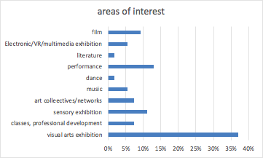

* 37% visual arts exhibition
* 7% classes, professional development
* 11% sensory exhibition
* 7% art collectives/networks
* 6% music
* 2% dance
* 13% performance
* 2% literature
* 6% Electronic/VR/multimedia exhibition
* 9% film

**Word cloud of open-ended responses:**

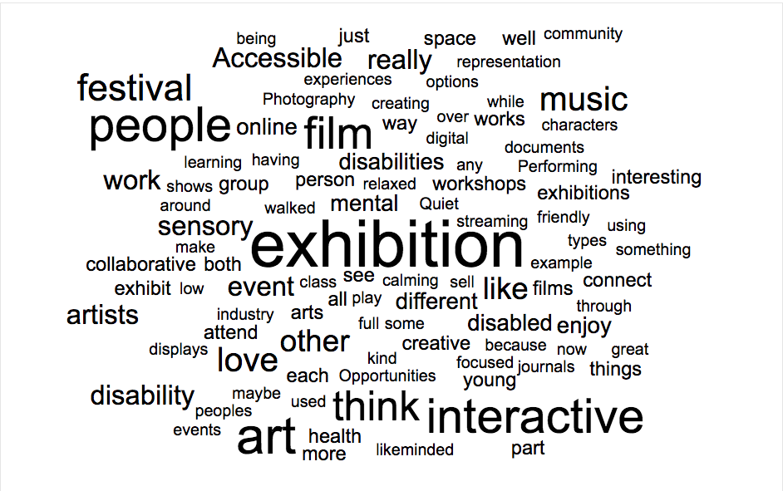

### There were a number of barriers faced by Young Disabled People when accessing arts activities:

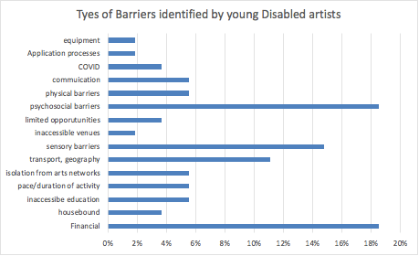

* 19% of respondents identified **Financial issues** as main barrier for participation in arts education or activities
* 19% identified **psychosocial barriers**, including anxiety, feeling unsafe, unwelcome, or unsure if mental health provisions could be accommodated
* 15% identified **sensory barriers**/lack of quiet spaces as main barriers
* 11% identified **transport** as a main barrier, including being unable to drive
* 6% identified expectations of **pace or duration** of creative participation as a main barriers (eg long hours in theatre rehearsals)
* 6% identified **physical barriers** as main reason for lack of participation
* Other descriptions like ‘housebound’, ‘inaccessible venues’, ‘isolation’ were slightly difficult to classify as social, geographic or physical.
* 2 participants mentioned the reduction of COVID restrictions like mask wearing and social distancing made participation in the arts inaccessible for them

**Quotes from the Survey:**

*“Other barriers I’m faced with include mobility difficulties such as being expected to stand for long periods of time at shows, programs etc. (then being told off for sitting down), sensory - noise, lights etc.”*

*“I wanted to study fine arts at uni a few years back, however it simply wasn't possible for me with the lack of online options, and the sheer quantity of spoons that getting places and making art uses up. I've been really enjoying zoom based drawing classes that came into being during covid, however a lot of those are starting to close down now that things are returning to in person”*

*“I have minimal energy to go out to places that other artist might find opportunities or connections in so I don't really find places to show or sell my art.”*

### Opportunities

Respondents wanted opportunities for recognition, funding, connection and community, enjoyment, process-driven activities without pressure of an end-goal, chances to show their work.

*“Connection & enjoyment- spaces I feel safe where I can re-engage in what I love and not worry about the end goal so much.”*

*“chances to show my work. to be seen and to feel a part of something.”*

### Connection to community:

* 29% felt connected to their community
* 37% felt connected AND disconnected to their community
* 52% felt only disconnected to their community

Quotes from the Survey:

*“I feel connected to the community within the context of my current tertiary arts education, but actually being able to use those skills or be employed, is close to impossible due to my disability. It makes me sad because I love what I am doing, but I know that it just can't be reality for me right now.”*

*“It is hard to find suitable support people, My mum is also disabled, We haven't a lot of money, Very few places are sensory safe, I have been too young or community classes are below my skills”*

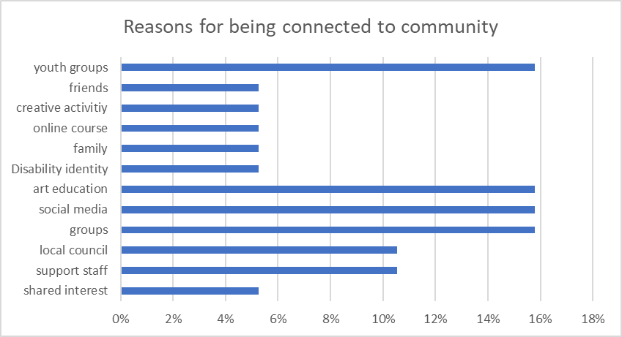

### Among the 19 responses describing themselves as ‘connected to community’:

* 16% cited youth groups or youth activities as factors that kept them connected
* 16% cited social media as key factor keeping them connected
* 16% cited other groups, eg Queer groups, social groups
* 11% cited local council activities and groups
* 11% cited Disabled support organisations and staff

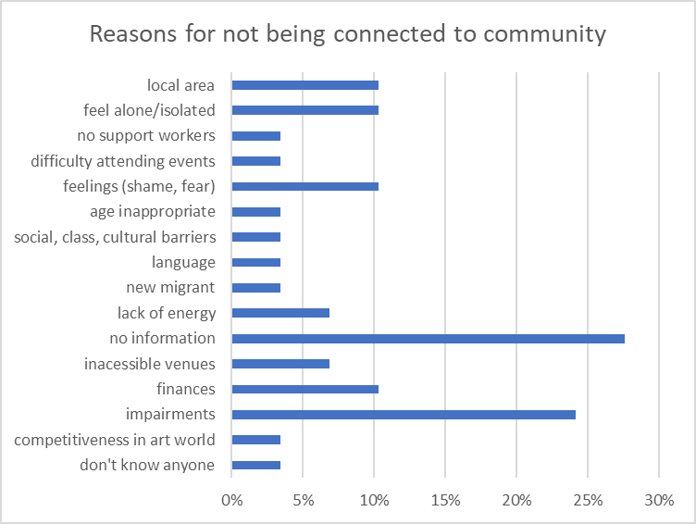

### Among the 29 responses describing themselves as ‘not connected to community’:

* 28% said they didn’t know how or where to connect with community
* 24% cited factors relating to their Disability: ie, no sensory spaces, inaccessible venues, exhaustion, chronic pain
* 10% cited lack of finances, or feeling alone, or ashamed or afraid

**Word cloud of open-ended responses:**

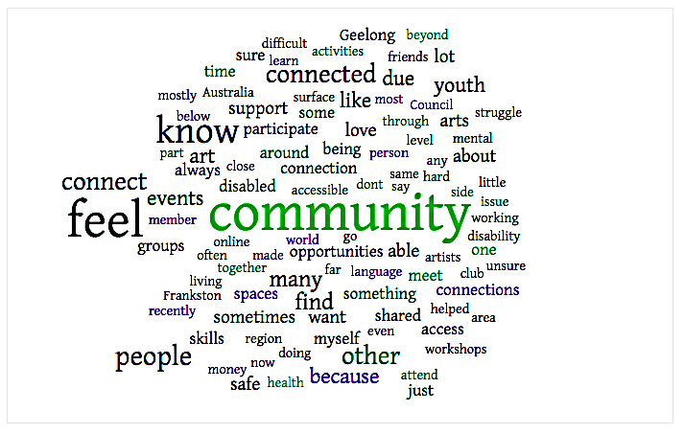

### Percentage of Disabled youth who connect with community in various spaces:

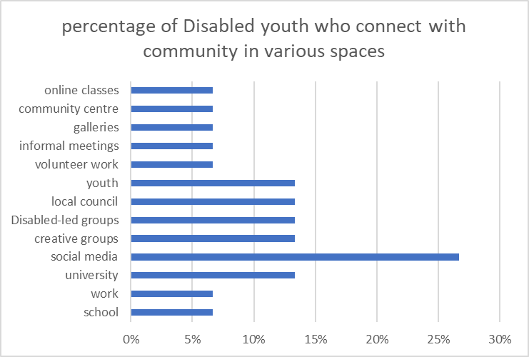

### 

* 27% connect on social media (Facebook, Twitter)
* 13% connect via local council and youth groups, or
* 13% connect via Disabled-led events, or spaces
* 13% connect via creative groups, or at university

### Key Reasons Disabled Youth don't have a place to connect to community:

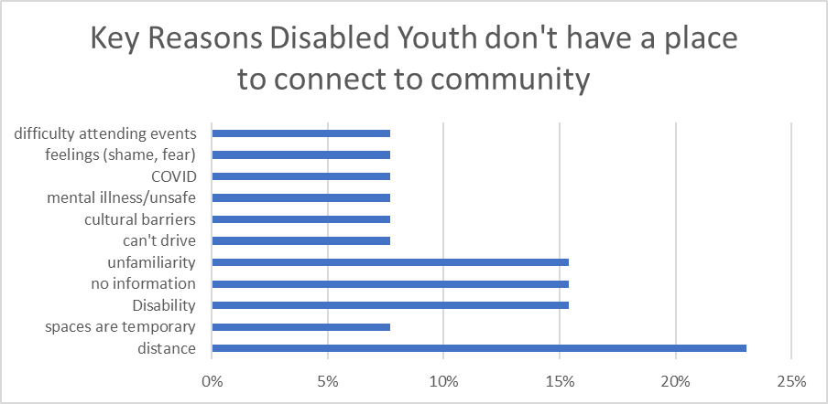

* 23% cited Distance from spaces they wanted to connect with
* 15% cited unfamiliarity or lack of information
* 15% cited access barriers, or impact of impairment on their capacity to connect to community.

### Preferred time

The best time for respondents to attend an arts program was on weekends or afternoons/evenings (general finding, not conclusive).

### Conclusions from survey analysis:

* Programs must be free of charge
* Visual arts exhibitions with sensory adjustments
* Provide broad access so that participants feel safe
* Programs must accommodate Crip Time
* Hybrid as a priority
* Consider access payments for participants, e.g. for transport
* Social media is an important place to connect
* Program weekends or afternoons/evenings

Please see attached report for full analysis.

## Literature Review (Dr. Margaret Mayhew)

### Creative programs for Young Disabled People in Australia

Information on creative programs for Young Disabled people in Australia is often obscured by two factors

1: The silo-ing of Disability and Youth as separate categories in the Arts

2: The structure of Government Disability funding across health, social security programs, and arts programs, at all three tiers of Government

The Commonwealth of Australia supports Disabled inclusion through three main pathways:

1. NDIS funding for art therapy programs for Disabled individuals
2. These may be through NDIS registered individual art therapists, of which there are 4000 in Victoria.
3. or through group programs at NGOs, or other companies.

The main arts organisations providing NDIS registered activities in Victoria are: Arts Access Victoria (Melbourne), Arts Project Australia (Melbourne), the DAX centre (Melbourne), Footscray Community Arts (Melbourne), Back to Back Theatre (Geelong), Create A (Bendigo), Factory Arts (Warrnambool). **Of these, Arts Access Victoria is the only organisation offering specific programs targeted for Young Disabled Artists.**

1. There are a broad range of NDIS registered Disability Service Organisations who offer art programs as part of their broader service provision to Disabled clients. The majority of art programs in regional Victoria are provided by Disability Service Organisations, such as accommodation providers, care providers, and local councils.
2. Information, Linkages and Capacity Building (ILC) Individual Capacity Building Program Grants managed by Department of Social Security

The ILC Capacity Building program grants were developed as a separate arm of the NDIA to promote an empowerment model of Disabled support, instead of the passive consumer role that may be implied by NDIS service provision.

The 2022-2023 funding round provided grants of between $50,000-$2,000,000 to 105 organisations nationally. **A total of $11.8 million dollars was offered for nine projects nationally promoting capacity building for Disabled youth.** By comparison $4,7 million was offered to six programs targeting Disabled children. However, none of these projects were related to creative practice. Only one organisation (Rebus Theatre in the ACT) was funded ($98,900) for a creative project.

Of the youth programs the following Victorian organisations were funded

1. Yellow Ladybugs Ltd VIC Autistic Women and Girls Yellow Link Programme $1,498,269.08
2. Children and Young People with Disability Australia (CYDA) VIC Victorian Emerging Young Leaders Program $1,026,282.40
3. Children and Young People with Disability Australia VIC National Youth Disability Leadership Program & In control our/my way, supporting NDIS self- management project $2,133,674.40
4. Australia Council for the Arts has programs for Disabled artists, and Younger artists (over 21), but not specifically Disabled young artists
5. Arts and Disability Initiative (6 grants of $30000)
6. National Arts and Disability Award (Established Artist) ($50,000).
7. National Arts and Disability Award (Early Career Artist) ($20,000).
8. Arts Access Australia’s National Leadership Award ($10,000).
9. Sync Leadership Program (mentorship and training, unpaid)
10. 3 awards for young creative practitioners: Martens Bequest ($50K over 2 years for practitioners in range of medium aged from 21-30),
11. Dal Stivens and Kathleen Mitchell awards (15,000 for writer under 30)
12. Supports youth arts eg Arena Theatre, St Martins Youth Arts Centre in Victoria

### State Government support

The Victorian Government’s State Disability Plan (2022-2026) commits to actions across 5 priority areas for inclusion of Disabled people

1. Education (directly targeting young people in schools and higher education)
2. Employment and Economic Participation
3. Voice and Leadership. This includes 4 specific areas promoting engagement of Disabled young people
4. Creative industries (discussed below)
5. Pride and Recognition

Creative Victoria provides information and partner funding for a range of Youth arts programs as well as Disabled arts programs, but not specifically targeting both.

IN addition to Disabled streams through individual arts grants programs like the Creators fund, Creative Victoria provided funding to the following Disabled arts projects:

* Loom Arts and Management, 200,000
* Weave Movement Theatre, 176, 405
* Flow Festival, 200,000
* Schizy Incorporated $146,000
* Find Your Voice, Warrnambool $200,000

None of the above projects targeted Deaf or Disabled Youth specifically.

Creative Victoria also offers Creative Learning Partnership grants for creative practitioners or organisations to work with young people in schools.

It also provides multi-year funding to a number of youth arts organisations including: Arena Theatre, Phunktional Arts, St Martin’s Youth Arts and SYN Media. Some of these funded organisations offer activities targeting Young Disabled artists.

### Local Government

City of Melbourne SIGNAL Youth Arts includes Disability specific programs undertaken in partnership with Arts Access Victoria and local schools.

City of Port Philip has a range of Disability Arts Services, including the Thrive Program (run with Arts Access Victoria) and supports the Disabled led theatre group Vitae Veritas. There was not clear mention of specific services for Disabled young people.

Darebin Council has a youth hub and a youth music centre, as well as providing a range of arts grants. They have a Disability Advisory group and an access and inclusion team, and community inclusion grants, but no explicit programs for Disabled creatives, or young Disabled people.

Merri-Bek Council has a range of arts grants and a Youth Space at Oxygen Centre. This runs programs in Visual arts, drama and music festivals, and provides grants. There are no specific programs for Young Disabled people. Council has a DAP and provides referral for local NDIS services.

Yarra Council provides arts and specific youth grants, but no Disability specific grants. They are also an NDIS provider, but do not offer specific arts support for Disabled people

Regional Victoria has a wide range of local government NDIS providers who offer arts programs.

### 4. Other organisations

Melbourne Fringe has specific programs for Disabled artists to develop and present work. It is not youth specific.

Midsumma Festival (Melbourne), has a Pathways program for LGBTIQA+ Disabled creatives wanting support to develop their practice and networks. These aren’t specifically targeted to young people.

Wild At Heart is an NGO providing support for Disabled musicians to record and share their work. It includes a lot of contemporary music and is linked to youth culture.

### 5. Summary from the Children and Young People with Disability Australia Budget Submission (2020-21):

9.3% of young people aged 15–24 years have disability. AIHW. (2020). *People with disability in Australia. Available at* People with disability in Australia, Prevalence of disability – Australian Institute of Health and Welfare (aihw.gov.au). This is a significant percentage of our population, yet funding for targeted Creative Programs is limited.

Young Disabled People are one of the most disadvantaged cohorts in the labour market and experience high rates of unemployment and underemployment. They experience the intersectionality of systemic disadvantage and oppression of both being a person with disability and a young person – with this disadvantage being even further amplified by other demographic factors, such as socio-economic status, ethnicity, gender or sexual diversity, or living in a regional or rural area. This disadvantage is expected to be entrenched as a result of the COVID-19 economic down-turn

Young Disabled People (Aged 15–25 years old) in the labour force are more than twice as likely to be unemployed than older Disabled adults (Aged 26–64 years old; 24.7 per cent compared to 7.9 per cent). AIHW. (2020). People with disability. Available at <https://www.aihw.gov.au/> reports/disability/people-with-disability- in-australia/contents/employment/ unemployment

Young Disabled People are also more than twice as likely to be underemployed — meaning they have the capacity and desire to work more hours than what they are currently employed. 23.1% per cent rate of underemployment compared to 8.3 per cent of older adults with disability; AIHW (2020).

Young people are disproportionately affected by the immediate and long-term economic and social impacts of the COVID-19 global pandemic. Within the youth cohort, young people with disability face increased marginalisation. Development and implementation of a COVID-19 youth recovery response is required to address inequities and mitigate negative, enduring consequences.

Creative programs that AAV develops for young people must be paid at industry rate and can focus on developing skills and networks to assist in the transition to further employment. For the full summary, please refer to attached documents.

## Key findings from desktop research

* For AAV, there is a gap in programming specifically for Young Deaf and Disabled artists.
* The majority of art programs in regional Victoria are provided by Disability Service Organisations (accommodation providers, care providers etc.) rather than Arts focused organisations.
* Funding for **creative practice** for young Deaf and Disabled people who do not have access to NDIS is limited.
* Not enough information is gathered about young Deaf and Disabled people - and most data is extrapolated from statistics on young people, or Disabled people.
* Young Deaf and Disabled people face serious barriers for financial stability, education and social inclusion
* Incarceration acts as an additional barrier for First Nations Deaf and Disabled youth (ND, hearing loss and cognitive impairments contributing to incarceration rates, which are then poorly managed in detention)
* Social exclusion is a grave and increasing issue for young Deaf and Disabled people
* Creative activity is recognised as a key contributor to social inclusion
* In Australia there is almost no funding for creative activities targeting young Deaf and Disabled people

# What has been developed?

## Values

The following values were developed and will be implemented across any future programming.

### The Youth Advisory Committee:

* A culture of respect and valuing diverse perspectives.
* Commitment to positive action.
* Commitment to nurturing our own and others’ inner artistic child.
* Inclusion, lived experience, acknowledgement of intersectionality, work ethic, disabled young people’s voices.
* We support and uplift each other.
* Different opinions are okay and have value.
* Participate in a way that makes you welcome. You are welcome to turn off your camera or use the chat.

### The Co-Design Workshops

* **Intentional accessible online and in-person space:** Being thoughtful of people with different circumstances.
* **Valuing expertise at all levels:** A supportive non-hierarchical space for all levels.
* **Innovative creativity:** We push the boundaries, grow and learn.
* **We Prioritise Community Connection:** Honouring the different types of community.

## Program Ideas

Below is an overview of the programs that have been developed. All programs have an online component or will be hybrid in delivery.

### Drop-in Maker Space

* Drop-in spaces, open to any Disabled artists to connect and create.
* Weekly or monthly online meetings.
* Focused on visual art and art that really benefits from a physical space that provides materials/equipment that Disabled artists might have a harder time accessing.
* There could be optional prompts/themes for artists to respond to.
* Open to different experience levels.
* Venue to be Signal.
* Pop up versions to happen in regional cities.
* Workshops to have a portion that is a guided workshop or has an industry guest.

### Paid ensemble residency

* Paid opportunities for a consistent group of Disabled artists over a few months to develop their work, with a few different groups throughout the year.
* To support Disabled artists who have less access to other opportunities/forms of support, this would prioritise disabled artists who aren’t on the NDIS and aren’t receiving other significant paid opportunities.
* Artform focus: performance.

### A quarterly disability arts magazine:

* A focus on promotion of disabled artists and building connections.
* The magazine will have an all-disabled editorial team.
* Submissions are open to Disabled people living in Victoria aged 16 and over.
* Contributors paid and open to different experience levels.
* There will be an online version that will take separate submissions for non-print art (eg videos).
* In collaboration with Sticky Institute and the Emerging Writers Festival.

## Evaluation

The evaluation of these future programs will be flexible. However, as a starting point AAV staff and co-design collaborators suggested these:

* Building authentic community engagement.
* Platforming the co-design collaborators and building storytelling.
* Meaningful spaces created by young people.
* The opportunities created by these programs are not siloed. It creates opportunity outside the programs.
* These programs have sustainability and is not a one off.
* Participants feel more confident and build meaningful connections.
* Helps people build sustainable arts practise and therefore better mental health.
* Participants gain knowledge they can use outside the programs.
* People come back and reengage with the programs.
* Having a lasting impact in the arts community.
* Connections and collaborations are fostered.
* There is potential to springboard into new programs.