QUT LogoParticipant information for QUT research project

– Image Release_Information Consent Form Artist + Creative Work–

Title of Research Project

**Evolution of Disability Arts in Australia**

QUT Ethics Approval Number 2021000382

**Image and Video Release**

The research team will take videos and voice recordings and/or photographs of you and/or your creative work as part of the research. We are asking your permission to store and use the image(s) and/or video and voice recordings of you and/or of your creative work.

The videos and voice recordings will identify you, and it is possible that people will become aware that you have been part of the research.

The research team wants to use these photographs, voice and video recordings in the following ways:

* to create an archive of disability arts in Australia,
* in publications and research presentations, created as part of this project, and
* in teaching and learning created from the Evolution of Disability Arts in Australia archive project.

**Information**

A photograph, video recording or voice recording of you and/or your work will identify you and this is personal information. The research team need to make sure that Queensland privacy principles are in place for recording, using and storing this information (see MOPP **F/6.2 Information Privacy** at <http://www.mopp.qut.edu.au/F/F_06_02.jsp>).

In the case of photographic images, video recordings, or voice recordings which capture images of your creative works – for instance, interviews conducted in your studio which capture images of your paintings – you own all intellectual property rights in that creative work. Accordingly, QUT and its research project partners must obtain your permission, as the copyright owner, in order to record and distribute any creative work created by you in accordance with the stated purposes (see MOPP **F/5.1 Copyright** at <http://www.mopp.qut.edu.au/F/F_05_01.jsp>).

QUT and its research project partners regularly reproduces photographic or audio-visual recordings of individuals and/or their creative work in its publications, promotional and marketing material and on websites operated by the University and University research partners. These Recordings are used for teaching, research, and other educational purposes, and may also be used to promote research projects and their outcomes.

We recommend that you take steps to ensure that you understand this document, which may include obtaining independent legal advice, before signing.

**Consent**

1. I have read and understand the information contained on this Form, and I agree that QUT may use, create copies and show to the public photographic, video, digital images and/or recordings containing my voice, information concerning me, and my creative work, for the stated purposes of the research project.
2. I agree to promptly inform QUT staff if I have any concerns after signing this Consent Form.
3. I understand that QUT may change or take any other action in relation to the recordings to give effect to the stated purposes of the research project.
4. Subject to the *Information Privacy Act 2009* (Qld) and MOPP F/6.2 (linked in privacy notice footer below), I understand that I may access a copy of the Recordings by providing a written request to QUT. I understand that QUT will provide access to, or a copy of, the Recordings in any medium deemed appropriate by QUT in its sole discretion.
5. I waive any right that I may have to review or approve the Recordings.
6. I understand that my permission and consent for QUT to use the Recordings may be revoked at any time by providing written notice to QUT, directing all enquiries to [bree.hadley@qut.edu](mailto:bree.hadley@qut.edu) or c.bowditch@artsaccess.com
7. I agree that I will make no claim against QUT for any payment or fee whatsoever and release QUT from any other claims arising out of, or in connection with, QUT’s capture, storage, use, reproduction and/or disclosure of the Recordings in connection with the stated purposes.

**If you sign this Consent and Release Form, you agree that QUT may use any Recordings of you and your work for the stated purposes. If you agree to provide your consent, please complete and return this Form to QUT.**

**A B C D …**

**Print your full name here:**

**Signature Icon**

**Sign here:**

**Date:**

**Please return the signed form to the researcher.**

**PLEASE RETURN THIS FORM TO QUT**

**The Research Team**

**The lead chief investigators are below:**

**Professor Bree Hadley wearing glasses

Professor Bree Hadley**

Chief Investigator

Qld University of Technology

[bree.hadley@qut.edu.au](mailto:bree.hadley@qut.edu.au)

**Professor Kathleen Ellis

**

**Prof Kathleen Ellis**

Chief Investigator

Curtin University

[katie.ellis@curtin.edu.au](mailto:katie.ellis@curtin.edu.au)

**More of the research team members:**

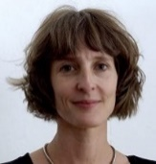Dr Christen Cornell

Partner Investigator

Australia Council for the Arts

[c.cornell@australiacouncil.gov.au](mailto:c.cornell@australiacouncil.gov.au)

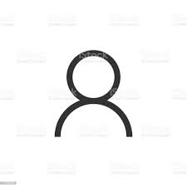Ms Caitlin Vaughan

Partner Investigator

Australia Council for the Arts [c.vaughan@australiacouncil.gov.au](mailto:c.vaughan@australiacouncil.gov.au)

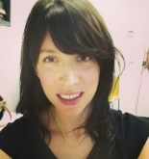Ms Erin Scudder

Research Assistant

The University of Melbourne [erin.scudder@unimelb.qut.edu.au](mailto:erin.scudder@unimelb.qut.edu.au)

**A/Prof Edward Paterson**

Chief Investigator

The University of Melbourne [eddiep@unimelb.edu.au](mailto:eddiep@unimelb.edu.au)

**A/Prof Janice Rieger**

Chief Investigator

QUT

[j.rieger@qut.edu.au](mailto:j.rieger@qut.edu.au)

****Ms Caroline Bowditch

Partner Investigator

Arts Access Victoria [cbowditch@artsaccess.com.au](mailto:cbowditch@artsaccess.com.au)

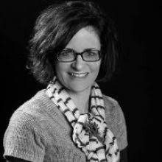Ms Annie Rolfe

Research Assistant

QUT

[a2.rolfe@qut.edu.au](mailto:r.missingham@qut.edu.au)

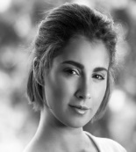

Ms Hannah Mason

Research

QUT

[Hannahleigh.mason@qut.edu.au](mailto:Hannahleigh.mason@qut.edu.au)

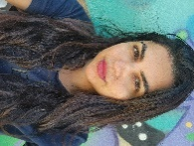Ms Saadia Ahmed

Research Assistant

Curtin University

saadia.ahmed@curtin.edu.au