QUT LogoParticipant information for QUT research project

– Image Release_Information Consent Form –

Title of Research Project

**Evolution of Disability Arts in Australia**

QUT Ethics Approval Number 2021000382

**Image and Video Release**

The research team would like to take videos and voice recordings and/or photographs of you as part of the research. We are asking your permission to store and use the image(s) and/or video and voice recordings of you.

The videos and voice recordings will identify you, and it is possible that people will become aware that you have been part of the research.

The research team wants to use these photographs, voice and video recordings in the following ways:

* to create an archive of disability arts in Australia,
* in publications and research presentations, created as part of this project, and
* in teaching and learning created from the Evolution of Disability Arts in Australia archive project.

You can decline this invitation without any consequences, and still be in the study.

As there are multiple participants, it will not be possible to request changes to the video recording, audio recording or photographs once participation commences.

Once the image and video is published it will not be possible to withdraw your consent.

**Statement of consent**

**By signing below, you are indicating that you:**

* Have read and understood the information about this image release.
* Have had any questions answered to my satisfaction.
* Understand if I have any additional questions I can contact the research team.
* Understand I am decline this invitation without comment or penalty.
* Understand that if I have concerns about the ethical conduct of the research project I can contact the Research Ethics Advisory Team on 07 3138 5123 or email [humanethics@qut.edu.au](mailto:humanethics@qut.edu.au).
* Understand that the research project will include a video recording, audio recording and images
* Understand that as there are multiple participants it will not be possible to request changes to the photographs, video recording or audio recording once participation commences.

**A B C D …**

**Print your full name here:**

**Signature Icon**

**Sign here:**

**Date:**

**Please return the signed form to the researcher.**

If you are unable to provide written consent the research team will be happy to video record your consent, given through your preferred communication modality – verbally, through Auslan, Deaf/Blind sign language, or a text-to-speech computer mediated communication device.

**Please return the signed consent form to the researcher.**

**A copy will be provided for your records.**

**The Research Team**

**The lead chief investigators are below:**

**Professor Bree Hadley wearing glasses

Professor Bree Hadley**

Chief Investigator

Qld University of Technology

[bree.hadley@qut.edu.au](mailto:bree.hadley@qut.edu.au)

**Professor Kathleen Ellis

Prof Kathleen Ellis**

Chief Investigator

Curtin University

[katie.ellis@curtin.edu.au](mailto:katie.ellis@curtin.edu.au)

**More of the research team members:**

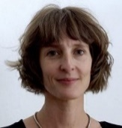Dr Christen Cornell

Partner Investigator

Australia Council for the Arts

[c.cornell@australiacouncil.gov.au](mailto:c.cornell@australiacouncil.gov.au)

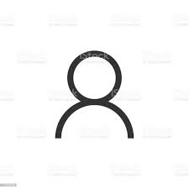Ms Caitlin Vaughan

Partner Investigator

Australia Council for the Arts [c.vaughan@australiacouncil.gov.au](mailto:c.vaughan@australiacouncil.gov.au)

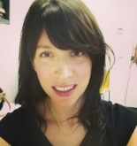Ms Erin Scudder

Research Assistant

The University of Melbourne [erin.scudder@unimelb.qut.edu.au](mailto:erin.scudder@unimelb.qut.edu.au)

**A/Prof Edward Paterson**

Chief Investigator

The University of Melbourne

[eddiep@unimelb.edu.au](mailto:eddiep@unimelb.edu.au)

**A/Prof Janice Rieger**

Chief Investigator

QUT

[j.rieger@qut.edu.au](mailto:j.rieger@qut.edu.au)

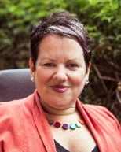Ms Caroline Bowditch

Partner Investigator

Arts Access Victoria [cbowditch@artsaccess.com.au](mailto:cbowditch@artsaccess.com.au)

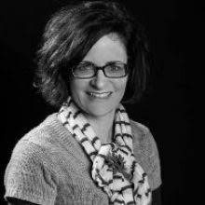Ms Annie Rolfe

Research Assistant

QUT

[a2.rolfe@qut.edu.au](mailto:r.missingham@qut.edu.au)

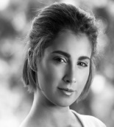

Ms Hannah Mason

Research

QUT

[Hannahleigh.mason@qut.edu.au](mailto:Hannahleigh.mason@qut.edu.au)

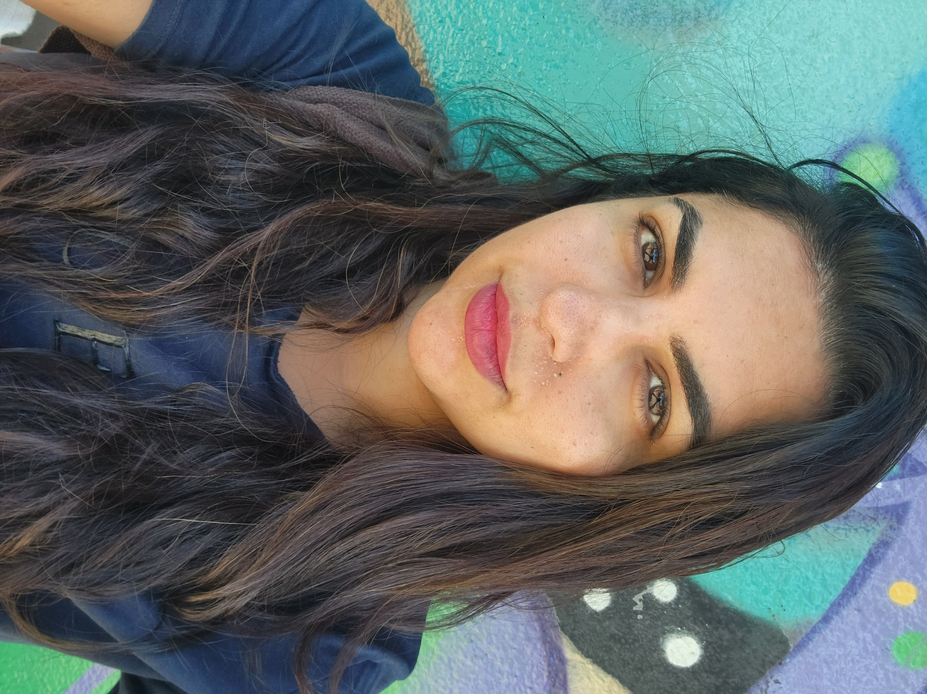Ms Saadia Ahmed

Research Assistant

Curtin University

saadia.ahmed@curtin.edu.au