QUT LogoParticipant consent for QUT research project – interview –

Title of Research Project

**Evolution of Disability Arts in Australia**

QUT Ethics Approval Number 2021000382

**Statement of consent**

**By signing below, you are indicating that you:**

* Have read and understood the information document regarding this research project.
* Have had any questions answered to your satisfaction.
* Understand that if you have any additional questions you can contact the research team.
* Understand that you are free to withdraw without comment or penalty.
* Understand that if you have concerns about the ethical conduct of the research project you can contact the Research Ethics Advisory Team on +61 7 3138 5123 or email [humanethics@qut.edu.au](mailto:humanethics@qut.edu.au).
* Understand that the research project will include a video recording.
* Agree to participate in the research project.

**A B C D …**

**Print your full name**

**here:**

**Signature Icon**

**Sign here:**

**Date:**

**Please return the signed consent form to the researcher.**

**Verbal Consent**

In signing this form at the direction of _____________________________, I confirm that he/she/they has read or had read to them, the content of the Information Statement and Consent Form and has made an informed choice to participate.”

**A B C D …**

**Print researcher**

**full name here:**

**Signature Icon**

**Researcher**

**Sign here**

**Date**

**Please return the signed consent form to the researcher.**

**The Research Team**

**The lead chief investigators are below:**

**Professor Bree Hadley wearing glasses

**

**Professor Bree Hadley**

Chief Investigator

Qld University of Technology

[bree.hadley@qut.edu.au](mailto:bree.hadley@qut.edu.au)

**Professor Kathleen Ellis

Prof Kathleen Ellis**

Chief Investigator

Curtin University

[katie.ellis@curtin.edu.au](mailto:katie.ellis@curtin.edu.au)

**More of the research team members:**

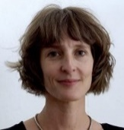Dr Christen Cornell

Partner Investigator

Australia Council for the Arts

[c.cornell@australiacouncil.gov.au](mailto:c.cornell@australiacouncil.gov.au)

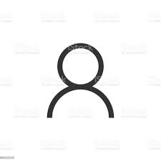Ms Caitlin Vaughan

Partner Investigator

Australia Council for the Arts [c.vaughan@australiacouncil.gov.au](mailto:c.vaughan@australiacouncil.gov.au)

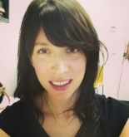Ms Erin Scudder

Research Assistant

The University of Melbourne [erin.scudder@unimelb.qut.edu.au](mailto:erin.scudder@unimelb.qut.edu.au)

**A/Prof Edward Paterson**

Chief Investigator

The University of Melbourne

[eddiep@unimelb.edu.au](mailto:eddiep@unimelb.edu.au)

**A/Prof Janice Rieger**

Chief Investigator

QUT

[j.rieger@qut.edu.au](mailto:j.rieger@qut.edu.au)

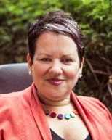Ms Caroline Bowditch

Partner Investigator

Arts Access Victoria [cbowditch@artsaccess.com.au](mailto:cbowditch@artsaccess.com.au)

Ms Annie Rolfe

Research Assistant

QUT

[a2.rolfe@qut.edu.au](mailto:r.missingham@qut.edu.au)

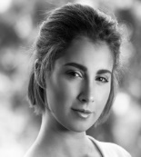

Ms Hannah Mason

Research

QUT

[Hannahleigh.mason@qut.edu.au](mailto:Hannahleigh.mason@qut.edu.au)

Ms Saadia Ahmed

Research Assistant

Curtin University

saadia.ahmed@curtin.edu.au