Future Reset – Maker Space Program Information
Creating community through art.
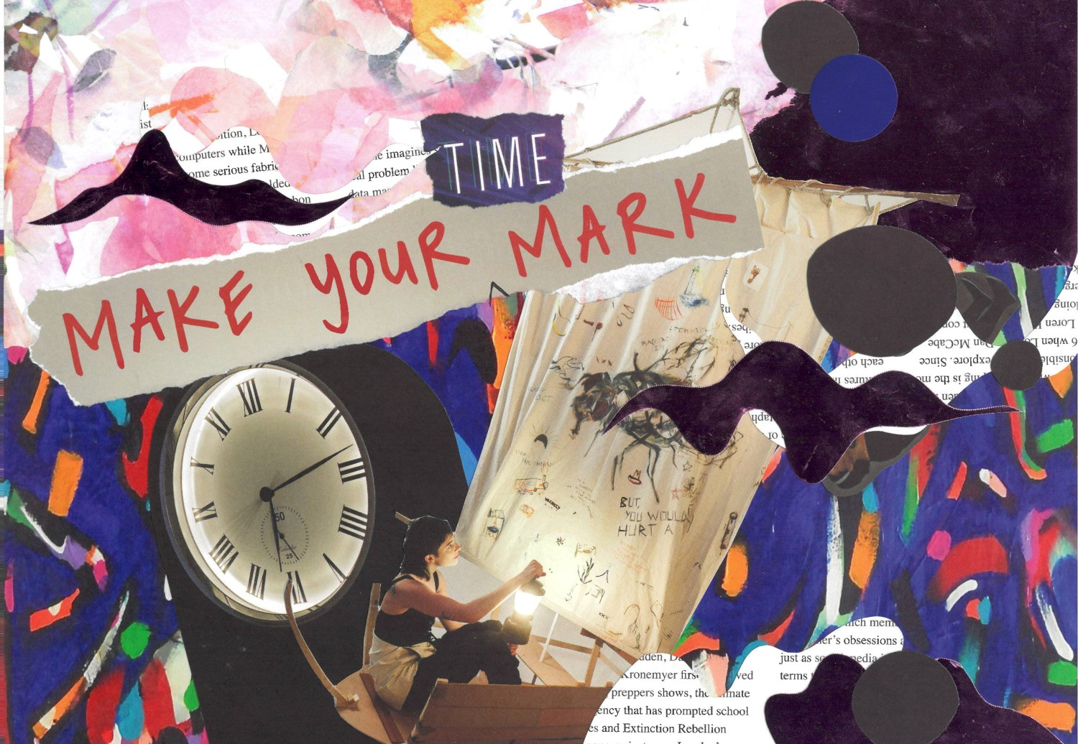
‘Make time—’ by Ash Hem

Contents
About Future Reset – Maker Space 3
About Arts Access Victoria 3
What to expect in the workshops 4
Workshop structure 5
AAV staff 7
Workshop artists 7
Venues 8
Supporting your access 13
Contact us 16

About Future Reset – Maker Space
Maker Space is a program co-designed with young Deaf and Disabled creatives. The aim of these workshops is to provide some of the resources, skills and connections going to a higher education program would provide. This program is free, adaptable to your access needs, low pressure and has the option of an outcome. We want to help you create a space where you can connect with your peers and create art.
Future Reset – Maker Space is in partnership with Arts Centre Melbourne and City of Melbourne’s SIGNAL program and supported by the Victorian Government through Engage! and VicHealth. It is part of a larger program called Future Reset.

About Arts Access Victoria
Arts Access Victoria (AAV) is the state’s peak body for arts and disability. Since 1974, AAV has been a leader in disability arts practice, access and cultural equity. AAV is disability-led. AAV produces and platforms the work of Deaf and Disabled artists. AAV’s goals are to:
- Define and build cultural equity for Deaf and Disabled people.
- Target and shift the barriers and conditions that maintain cultural inequity.
- Position AAV as a resilient and dynamic powerhouse to extend its role and impact.
We want everyone represented in all areas of the arts, screen and creative industries. Art is a tool for change. We celebrate the aesthetic potential of disability and access. We share authentic stories that are ours to tell. We produce and platform excellence in disability arts and culture.
AAV shares unique and untold stories that challenge the issues that frame the lives of Deaf and Disabled people. It places Deaf and Disabled artists, not at the margins, but centre stage. Recognising them instead as significant and invaluable contributors to the Australian cultural landscape.

What to expect in the workshops
The artist leading the workshop will teach you skills and give you guidance. We encourage you to participate in whatever way is most comfortable to you. If you don’t want to share or if there is an activity you are not comfortable with, let us know.
We do our best to make the workshops a sensory safe space. However, there may be elements beyond our control. If you want to know something specific about any of the venues, staff or anything that is not covered in this document, please get in touch with us.

In person workshops
The first half of the workshops will be guided by a Deaf and/or Disabled artist. They will teach you a new skill, how to make something or run guided experimentation. This will run for 1.5 hours or 2 hours. There will be short breaks.
There will then be a lunch break. Please bring your own lunch.
You will then have free use of the space to create, experiment, socialise and more. Materials will be provided. Facilitators and support workers will be available to you if you would like support.

Online workshops
The online workshops will be on Zoom. They will be run by a Deaf and/or Disabled artist who will demonstrate and teach you a new skill or how to make something. There will also be breaks.
We will send an email out with the Zoom link before the workshop day. You can use the link to join Zoom. Feel free to participate in whichever way makes you feel comfortable. If you’d like to have your camera off or only use the chat function that is totally fine.
Please note that the online workshop will cover what was taught in the in-person workshop. The content will be modified to suit the online space. Because we need to ship out materials a week beforehand, please sign up as early as you can. Sometimes the post can be unpredictable. If the materials do not arrive in time, we encourage you to still come along. Let us know so we can adjust the workshop for you.

Workshop structure
In person – Saturdays 11:30am-3:30pm
Hybrid (in Term 4) – Saturdays 11:30am-1:30pm
Online – Wednesdays 6-8pm on Zoom

Term 1 – illustration and photoshop (digital arts) with Ashley Ronning
- Saturday 2 March 2024 Visual Arts (SIGNAL)
- Wednesday 13 March 2024 Visual Arts online on Zoom
- Saturday 16 March 2024 Visual Arts (SIGNAL)
- Wednesday 20 March 2024 Visual Arts online on Zoom
- Saturday 23 March 2024 Digital Arts (The Channel)
- Wednesday 27 March 2024 Digital Arts online on Zoom
TBC Excursion in April
Library at the Dock – 3D printing + venue tour

Term 2 – Acrylic painting on canvas with Luke King and digital storytelling with Seb Fowler
- Saturday 4 May 2024 Visual Arts (SIGNAL)
- Wednesday 8 May 2024 Visual Arts online on Zoom
- Saturday 18 May 2024 Visual Arts (SIGNAL)
- Wednesday 22 May 2024 Visual Arts online on Zoom
- Saturday 8 June 2024 Digital Arts (The Channel)
- Wednesday 12 June 2024 Digital Arts online on Zoom

Term 3 – printmaking with Luke King and digital storytelling with Seb Fowler
- Saturday 15 June 2024 Visual Arts (SIGNAL)
- Wednesday 19 June 2024 Visual Arts online on Zoom
- Saturday 29 June 2024 Visual Arts (SIGNAL)
- Wednesday 3 July Visual Arts online on Zoom
- Saturday 13 July 2024 Digital Arts (The Channel)
- Wednesday 17 July 2024 Digital Arts online on Zoom

Term 4 – professional development and digital accessibility
- Saturday 27 July 2024 hybrid at AAV and Zoom – exhibition planning with Curator
- Saturday 10 August 2024 hybrid at AAV and Zoom
- Saturday 17 August 2024 hybrid at AAV and Zoom
- Wednesday 28 August 2024 Digital Arts online on Zoom
- Saturday 31 August 2024 Digital Arts (The Channel)

Term 5 – Exhibition prep/studio time at SIGNAL (Saturdays) and online (Wednesdays)
- Saturday 7 September 2024
- Wednesday 11 September 2024
- Saturday 21 September 2024
- Wednesday 25 September 2024
- Saturday 5 October 2024
- Wednesday 9 October 2024
- Saturday 12 October 2024

Exhibition at Library at the Dock and online
- 30 Oct – 24 Nov
- Opening night function: Thursday 31 Oct

End of year exhibition note
All workshop participants can apply to be part of the end of year exhibition. Those who attended the Future Reset – Maker Space program will be prioritised over those who haven’t attended the workshops more regularly. Artworks will be selected through an Expression of Interest process. As much as we want to include everybody, there may be limited spots. We will let you know when the EOI is open.

AAV staff
All the workshops will have Arts Access Victoria staff present.
- In-person and hybrid workshops will have a support worker, a facilitator and a guest artist
- Online will have a facilitator and a guest artist
There will also be Signal and Arts Centre Melbourne support staff present.

Workshop artists
Term 1 – Ashley Ronning
Term 2 & 3 – Luke King and Seb Fowler
Term 4 & 5 – AAV staff and facilitators

Venues

Signal - Northbank, Flinders Walk, Melbourne VIC 3000
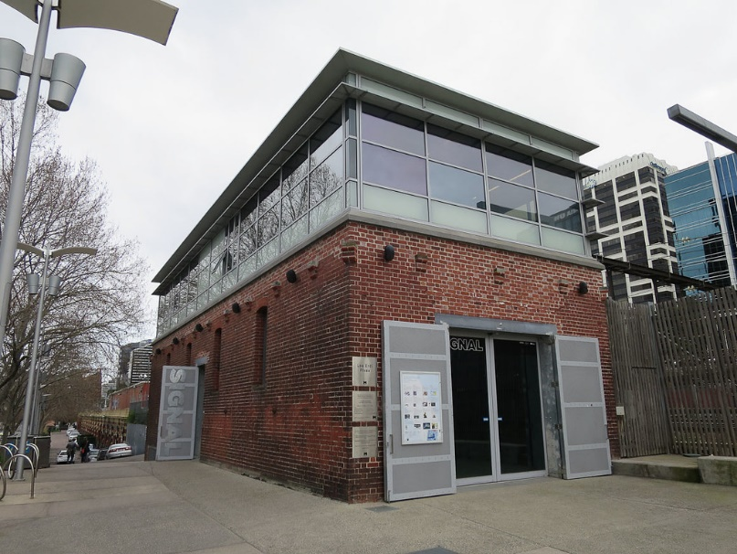

About the venue
Signal is a creative studio for young people. It has two studio spaces. We will be using the downstairs one. There is a small kitchen, two bathrooms (one that is accessible) and a lift. You can put your lunch in the kitchen fridge and make yourself a tea. Signal is wheelchair accessible. The kitchenette can be used as a quiet space, or if it is busy during lunchtime, you’re welcome to use the computer lab area upstairs.

Getting to Signal
Signal is right in the heart of the city: behind Flinders Street Station on Northbank, in the Les Erdi Plaza, at the northern end of Sandridge Bridge, and at the top of Banana Alley.
Signal is accessible by public transport and there is bike parking (but no car parking) on site.

Sensory information for Signal

Noises
- As it is located right next to the station, you should expect the sound of trains. Inside the venue the sound is faint.
- Skateboarders will occasionally practise nearby.
- There are a lot of commuters passing by.
- There will be another workshop upstairs.

Smells
- As Signal is located in the city, there is a possibility that there will be strong smells. However, we will keep the inside as scent free as possible.
- If we use materials with a strong smell, we will let you know in advance and open the doors.

Visuals
- There is virtual tour if you want to check out SIGNAL before you come.
- There is a lot of natural light through the front doors.
- There are theatre curtains available to cover the front doors.
- There are no flickering lights.

Temperature
- There is temperature control.

The Channel - Arts Centre Melbourne, St Kilda Rd Terrace, Southbank VIC 3006
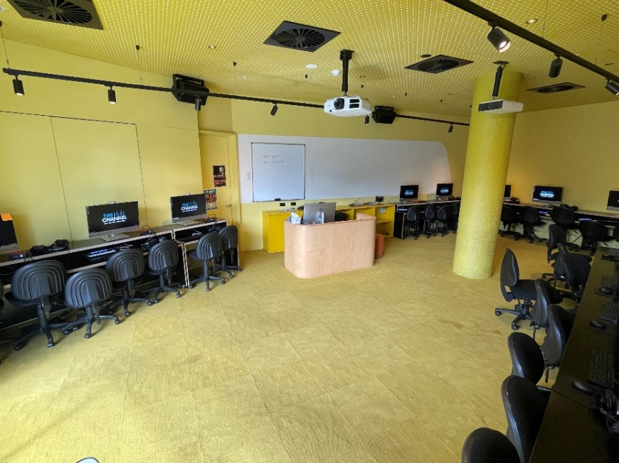

About the venue
The Channel is Arts Centre Melbourne’s learning and participation venue. There are two learning lab spaces and a performance space. We will be using the yellow room. The Channel is wheelchair accessible. There will be a quiet space set up for the workshops.
There is a kitchenette and three gender neutral bathrooms (one that is wheelchair accessible).
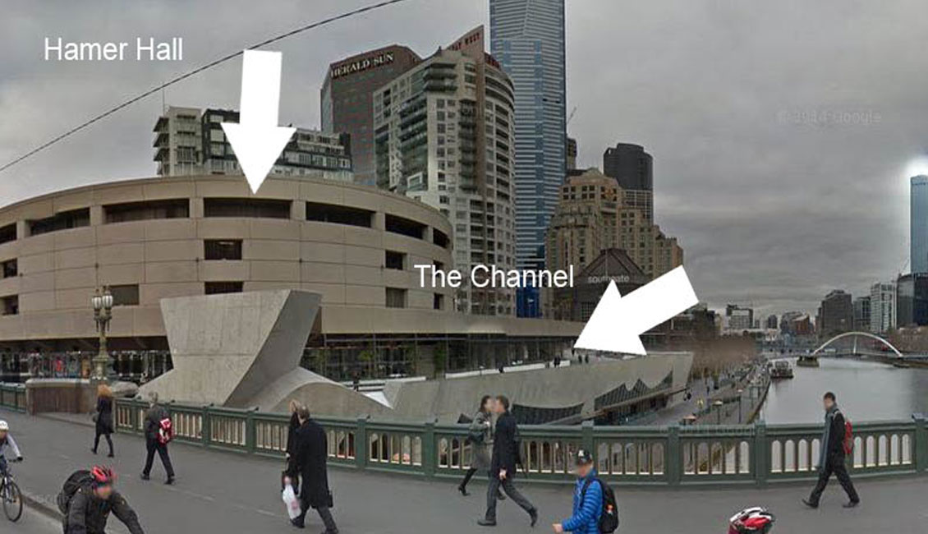

Getting there
The Channel is located between Hamer Hall and Southgate shopping mall. It is by the Yarra riverbank on the Southbank Terrace, across the street from Flinders Street Station.
The Channel is accessible by public transport and there is bike parking (but no car parking) on site. If you are coming from Flinders Street Station, make your way towards Hamer Hall and turn right at the end of Princess Bridge. The Channel will be on your left.
You can download a map from The Channel website.
Video on how to get to the Channel from Flinders St. It’s a bit old – you won’t see the white fences set up once you turn left at Hamer Hall.

Sensory information for The Channel

Noises and pedestrians
- Skateboarders will occasionally practise nearby.
- There will be pedestrians passing throughout the day.
- Occasionally curious pedestrians will try to look through the windows or front glass door of The Channel. If this happens during the workshop, please let AAV or The Channel staff know and we will manage them.

Smells
- As The Channel is located in the city, there is a possibility that there will be strong smells. However, we will keep the inside as scent free as possible.
Temperature
- There is temperature control.

Arts Access Victoria - 222 Bank St, South Melbourne VIC 3205
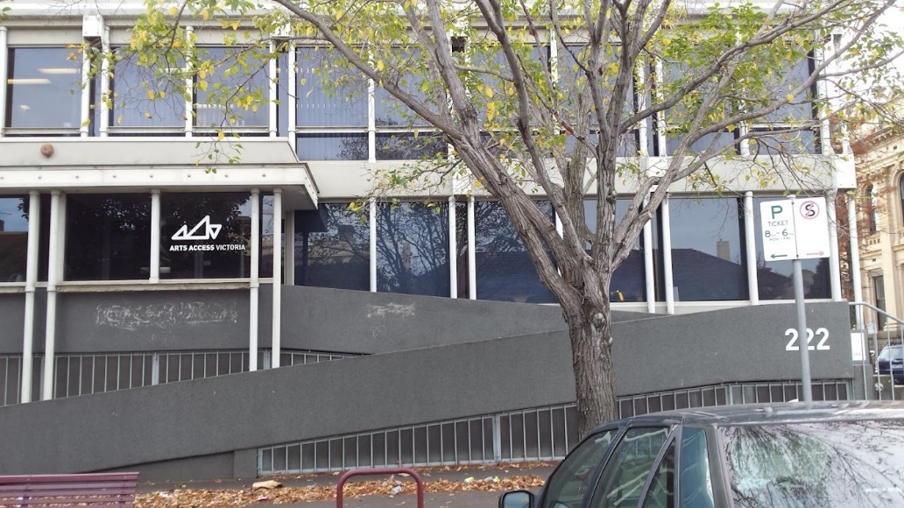

About the venue
The Arts Access Offices have dim lighting. You have to go up a ramp or steps to get inside. There are three bathrooms (one accessible), a kitchen and a quiet space. You are welcome to tea and coffee in the kitchen. The workshops will be held in the board room. There is a quiet space permanently set up in the AAV office.

Sensory Information for the AAV office

Noises
- There is a loud bell that rings every hour nearby.
- In the reception area you can hear people outside.
- Sometimes you can hear the heating system.
Smells
- Arts Access Victoria avoids using or having scented items.
Temperature
- There is temperature control.

Getting there
Arts Access Victoria is located on the ground floor of 222 Bank Street (cnr Fishley St), South Melbourne, which is off Clarendon Street, just up from the South Melbourne Town Hall. You can view the map and instructions how to get there on the AAV website.

Supporting your access
We acknowledge everybody’s right to self-identify and respect how you identify.
We use the term ‘Deaf and Disabled people’ in line with the Social Model of Disability. We use this definition as an act of pride and solidarity.
Access is an ongoing conversation. It’s okay if you don’t know right away what your access requirements are. You can always let us know once you do.
Here are some examples of what access requirements people ask for:
- Auslan interpreters
- Information in advance
- A quiet space
- Seating
- A note taker
- Low lighting
- Live captioning
- Easy Read documents
- Support worker
- Facilities for support animal
- Conversation cards
You are welcome to bring your own support worker, but they must only provide support to you.
There are many other things that you can ask for. If you are experiencing a barrier to attending this program, please reach out to us. Together we can come up with a solution.

Social Expectations
- Dress code: Come in whatever you feel comfortable in.
- You do not have to disclose anything that makes you uncomfortable. Sharing your knowledge is enough.
- We encourage you to participate in a way that is comfortable. You are welcome to turn your camera off, use the chat, lay on the floor, get up to stretch and so on.
- Support workers are very welcome. However, they are there to support and not insert their perspective.
- While we try and give you as much information as possible, there will be times where we will be stepping into the unknown.
- There is a possibility that access needs will clash. We will work together to find a creative solution.
- We acknowledge and respect the different perspectives and backgrounds of everybody in the room.
- We acknowledge, respect and do our best to include perspectives that may not be in the room.
- We listen, we take the time to learn from each other and respect the decision not to share.
- Boundaries are welcome.
- You can step out at any point if you need air, quiet space or just need to leave.

Filming and Photography
There may be a photographer at the in-person workshops. These photos will be used to promote the workshops and show our funders what we have delivered. If you do not want your photo taken please let staff know. We will have a ‘no photography’ sticker you can use. We will also hand out media release forms so you can detail how we can and cannot use your image.

Survey
We will be asking you to provide feedback at the end of each term you attend. This will help us improve the overall program for next year. It will also help us apply for funding for this program in the future. We will have a survey for you to fill. If you want to give your feedback in a different way, we can accommodate.

Conflict
In the unlikely case of conflict, the facilitator and a support worker will be there to mediate. We may take a break and speak to individuals. If you need to remove yourself from a situation, there is space for you to do so.
If the issues can’t be resolved on the day, the facilitator and support worker will escalate it to the Youth Programs Creative Producers.

Contact us

General enquiries
Email: info@artsaccess.com.au
Phone: 03 9699 8299 (voice only)/ 0401 224 864 (text or voice)

Future Reset – Maker Space Enquiries
Email CJ Jonathan at cjonathan@artsaccess.com.au
Or Arty Owens at aowens@artsaccess.com.au

