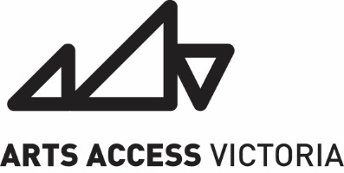
ANNUAL GENERAL MEETING
Tuesday 28th April 2026
Time: Apr 28, 2026 07:00 PM Canberra, Melbourne, Sydney
Join Zoom Meeting:
https://us02web.zoom.us/j/82732745726
Meeting ID: 827 3274 5726
Passcode: AGM1974
Access: Auslan interpreting, live captioning, wheelchair accessible venue and toilets
Contact: Joshua Pether - 0421776748

AGENDA

- Welcome (Nic) – 3 mins
  - Acknowledgement of Country
- Apologies (Nic)- 3 mins
- Minutes of Previous Annual General Meeting (Nic)- 3 mins
- Chair’s Report (Nic) – 10 mins
- CEO’s Report (Josh) -10 mins

- Audited Statement of Accounts (Sarg)- 10 mins
- Election of Auditor (Sarg) – 3 mins
- Appointment of Public Officer (Nic reappoints Josh) – 3 mins
- Election of Members to the Board of Arts Access Victoria (Nic) – 3 mins
- Election of Laine and Rosie to board
- Other Business (Nic)- 3mins
- Artist Presentation Charlie Boscolo – 9 min
Biography

Charlie Boscolo is an multifaceted actor and singer based in Narrm. He works across screen, stage, has studied at various institutions (16th Street, Brave Studios) and holds a Bachelor of Arts in Musical Theatre from Federation University. Charlie is currently part of the Arts Access Acting Mentorship Program and is a recipient of the ArtsPay Artist grant.

Charlie has performed in a range of productions across Melbourne's stages, including It’s Like a Circle (Melbourne Fringe), Ordinary Days (BeYou Productions), Angel with the Blue Eyes (Midsumma), and Sweetpea (Theatre Works). Most recently, he appeared in the Visit Victoria advertising campaign.

With a background in Alexander Technique and as certified Pilates instructor, Charlie takes pride in delivering warm, grounded and embodied performances. He is passionate about storytelling that advocates for disabled and queer characters, drawing on his personal experience as a visually impaired, autistic, transgender male actor.

- Close (Nic)
Please stay on for an informal chat after the meeting.

